

Disaster Recovery Plan
2016

19/10/2015, Rio de Janeiro, Brazil

Marco Teixeira, NEG

TABLE OF CONTENTS

1.- Glossary 4
2.- Overview 4
2.1 Policy Statement 4
2.2 Introduction 4
2.3 Confidentiality Statement 4
2.4 Manual Distribution 4
2.5 Defined Scenario 4
2.6 Recovery Objectives 5
2.7 Recovery Strategies 5
2.8 Probability and Impacts 5
2.8.1 Total Failure on Miami Router 7
2.8.2 Total Failure on Miami Switch 7
2.8.3 Total Failure on São Paulo Router 7
2.8.4 Total Failure on São Paulo Stack 7
2.8.5 Total Failure on Porto Alegre Stack 7
2.8.6 Total Failure of Santiago Router 7
2.8.7 Total Failure of Santiago Stack 7
2.8.8 Total Failure of Panama Router 8
2.8.9 Total Failure of Panama Stack 8
2.8.10 Total Failure of Arica Stack 8
2.8.11 Total Failure of Peru Stack 8
2.8.12 Total Failure of Ecuador Stack 8
2.8.13 Total Failure of Argentina Router 8
2.8.14 Total Failure of Argentina Stack 8
2.8.15 Total Failure of Costa Rica Stack 9
2.8.16 Total Failure of El Salvador Stack 9
2.8.17 Total Failure of Guatemala Stack 9
2.8.18 Total Failure of Mexico Stack 9
2.8.19 Total Failure of Venezuela Stack 9
2.8.20 Backbone interface failure 9
2.8.21 Backbone link failure 9
2.8.22 NREN access interface failure 9
2.8.23 NREN access link failure 9
2.8.24 ITN outage 10
2.8.25 Increased CPU in a ring equipment 10
2.8.26 Increased CPU in an access equipment 10
2.9 Notification Calling Tree 10
3.- Pre Issue 11
3.1 Backup Procedure 11
3.1.1 What data to Backup? 11
3.1.2 What Is Your Backup Method? 11
3.1.3 How Are Backups Scheduled? 11
3.1.4 Where the backup can be found? 11
3.2 Monitoring 11
3.2.1 How to Monitor 12
3.2.2 Remote Access 12
4.- During Issue 12
4.1 Hardware Issue 12
4.1.1 Hardware Issue Procedure 12
4.2 Software Issue 13
4.2.1 Software Issue Procedure 13
4.3 Security Issue 13
4.3.1 Security Issue Procedure 13
5.- After Issue 14
5.1 Recovery Report 14
6.- Recovery Strategies 14
6.1 Vlan extension 14
6.1.1 NRENs access backup sample 15
6.1.2 Commodity backup sample 16
6.2 Switch redundancy 17
6.3 Backup interface 17
6.4 Backbone Link redundancy 17
6.5 Nren access Link monitoring 18
6.6 Redundant ITN peering 18
6.7 CPU monitoring 18
7.- Preventive measures for avoiding or minimize failures 19
7.1 Spare parts 19
7.2 Network backup routes 19
7.3 Vlans 19
7.4 Writing of procedures for recovery 19
8.- Recommendations and conclusions 20
8.1 Miami Router Change 20
8.2 Argentina Router Change 20
8.3 Topology Change 20
Annex A 21

- Glossary
CLARA – Cooperación Latinoamericana de Redes Avanzadas
NEG – Network Engineering Group
NOC – Network Operations Center
NREN – National Research and Education Network

- Overview
  - Policy Statement
It is the Policy of RedCLARA to maintain a comprehensive technical continuity plan for the telecommunication structure. Each department head is responsible for ensuring compliance with this policy and that their respective plan component is tested no less than annually.

  - Introduction
This plan designed to guide RedCLARA through a recovery effort of specifically identified telecommunication function. At the onset of an emergency condition, RedCLARA employees and resources will respond quickly to any condition, which could affect RedCLARA’s ability to perform its critical technical functions. The procedures contained within have been designed to provide clear, concise and essential directions to recover from varying degrees of technical interruptions and disasters.

  - Confidentiality Statement
This manual is classified as the confidential property of RedCLARA. Due to the sensitive nature of the information contained herein, this manual is available only to those persons who have been designated as plan participants, assigned membership to one of the RedCLARA recovery teams, or who otherwise play a direct role in the recovery process. This manual remains the property of RedCLARA and may be repossessed at any time. Unauthorized use or duplication of this manual is strictly prohibited and may result in disciplinary action and/or civil prosecution.

  - Manual Distribution
Each plan recipient will receive and maintain two (2) copies of the disaster recovery manual; one copy will be kept in the plan recipient’s work area; the second copy will be kept at the plan recipient’s residence. Each manual has a control number to track its distribution. Replacement manuals and additional copies may be obtained from RedCLARA’s Disaster Recovery Manager.

  - Defined Scenario
A disaster is defined as a disruption of normal technical functions where the expected time for returning to normalcy would seriously affect Sample’s ability to maintain customer commitments and regulatory compliance. RedCLARA’s recovery and restoration program is designed to support a recovery effort where RedCLARA would not have access to its facilities and data at the onset of the emergency condition.

  - Recovery Objectives
The RedCLARA Plan was written with the following objectives:

- To ensure the life/safety of all RedCLARA’s equipment throughout the emergency condition, disaster declaration, and recovery process.

- To reestablish the essential organization related services provided by RedCLARA within their required recovery window.

- To mitigate the impact to RedCLARA’s customers through the rapid implementation of effective recovery strategies as defined herein.

- To reduce confusion and misinformation by providing a clearly defined command and control structure.

- To consider relocation of personnel and facilities as a recovery strategy of last resort.

- To achieve a Disaster Recovery Time of 4 hours or less for the RedCLARA’s main trunk.

  - Recovery Strategies
In order to facilitate a recovery regardless of the type or duration of disaster, RedCLARA has implemented multiple recovery strategies. These strategies are categorized into three (3) levels. Each level is designed to provide an effective recovery solution equally matched to the duration of the emergency condition.

- LEVEL 1: SHORT-TERM OUTAGE (RIDE-OUT) – INTRA-DAY
A short-term outage is defined as the period of time RedCLARA does not require external support for operations, and where an outage window at the same day would allow restoring / repairing the specific problem.

- LEVEL 2: MEDIUM-TERM OUTAGE (TEMPORARY) – UPTO ONE WEEK
A medium-term outage is defined as the period that RedCLARA will execute its formal disaster recovery strategy, which includes actually declaring a disaster. The decision to declare a disaster will be based on the amount of time / expense that is required to implement the formal recovery and the anticipated impact to RedCLARA’s operations over this period.

- LEVEL 3: LONG-TERM OUTAGE (RELOCATION) – 1 WEEK OR MORE
A long-term outage is defined, as the period of time that RedCLARA will exceed the allowed occupancy time of its primary recovery strategy. During this phase of recovery, RedCLARA will initiate several physical moves of equipment’s and employees to repair the network in the shortest possible time.

  - Probability and Impacts
In order to measure the impacts of a failure a risk matrix was created and every issue was added with it specific probability. All the risks have a description to show the impacts that the failure generate in the network.

Risk Nº | Risk | Impact | Probability
1 | Total Failure on Miami Router | Very High | Very Low
2 | Total Failure on Miami Switch | Medium | Low
3 | Total Failure on São Paulo Router | Very High | Very Low
4 | Total Failure on São Paulo Stack | Very High | Low
5 | Total Failure on Porto Alegre Stack | Medium | Low
6 | Total Failure on Santiago Router | Very High | Very Low
7 | Total Failure on Santiago Stacks | Very High | Low
8 | Total Failure on Panama Router | Very High | Very Low
9 | Total Failure on Panama Stack | Very High | Low
10 | Total Failure on Arica Stack | Very High | Low
11 | Total Failure on Peru Stack | Very High | Low
12 | Total Failure on Ecuador Stack | Very High | Low
13 | Total Failure on Argentina Router* | Very High | Low
14 | Total Failure on Argentina Stack | Very High | Low
15 | Total Failure on Costa Rica Stack | Very High | Low
16 | Total Failure on El Salvador Stack | Very High | Low
17 | Total Failure on Guatemala Stack | Very High | Low
18 | Total Failure on Mexico Stack | Very High | Low
19 | Total Failure on Venezuela Stack | Very High | Low
20 | Backbone Interface Failure | Medium | Very Low
21 | Backbone Link Failure | Medium | Medium
22 | NREN Access Interface Failure | Very High | Low
23 | NREN Access Link Failure | Very High | Medium
24 | ITN Outage | High | Medium
25 | Increased CPU in a Ring Equipment | High | Low
26 | Increased CPU in a Access Equipment | Medium | Low
Note: An annex follow the document showing the MTBF of each equipment. Every equipment that passes the MTBF time should have a greater probability of fail.

Probability | Very High
Probability | High
Probability | Medium |  |  | 21 | 24 | 23
Probability | Low |  |  | 2,5 | 25,26 | 4,7,9-19
Probability | Very low |  |  | 20, |  | 1,3,6,8,22
 |  | Very Low | Low | Medium | High | Very High
 |  | Impact

    - Total Failure on Miami Router
In the event of a total failure on Miami router, the network will have the following impacts:
- Lose the commodity service.
- Lose access to LAN servers
- Lose primary connection to some ITNs (Internet2,ESNET,CANARIE)
- Lose all L3 services provided

    - Total Failure on Miami Switch
In the event of a total failure on Miami Switch, the network will have the following impacts:
- Lose the commodity service to Cogent/Terremark
- Lose access to LAN servers

    - Total Failure on São Paulo Router
In the event of a total failure on Sao Paulo router, the network will have the following impacts:
- Lose connection to RNP and ARANDU NRENs.
- Lose access to LAN servers
- Lose backup/main connection to some ITNs ( Geant,ESNET,Internet2 )
- Lose all L3 services provided

    - Total Failure on São Paulo Stack
In the event of a total failure on Sao Paulo stack, the network will have the following impacts:
- Lose connection to RNP and ARANDU NRENs.
- Lose access to LAN servers
- Lose backup/main connection to some ITNs ( Geant,ESNET,Internet2 )
- Lose connection to CLARA-CL,CLARA-PA and CLARA-US direct links.

    - Total Failure on Porto Alegre Stack
In the event of a total failure on Porto Alegre stack, the network will have the following impacts:
- Lose connection to one backbone link (Clara-BR | Clara-AR)

    - Total Failure of Santiago Router
In the event of a total failure on Santiago router, the network will have the following impacts:
- Lose connection to REUNA, RAAP and CEDIA NRENs.
- Lose connection to RedCLARA office.
- Lose access to LAN servers
- Lose all L3 services provided
- Lose all L2 services provided (Aura Backup route)

    - Total Failure of Santiago Stack
In the event of a total failure on Santiago Stack (Level3), the network will have the following impacts:
- Lose the main path to connect REUNA, RAAP and CEDIA NRENs .
- Lose direct connection to CLARA-PA , CLARA-US and CLARA-BR

In the event of a total failure on Santiago Stack (Silica), the network will have the following impacts:
- Lose connection to REUNA, RAAP and CEDIA NRENs.
- Lose connection to RedCLARA office.
- Lose access to LAN servers
- Lose all L3 services provided
- Lose all L2 services provided (Aura Backup route)

    - Total Failure of Panama Router
In the event of a total failure on Panama router, the network will have the following impacts:
- Lose connection to CONARE,REDCyT,RAICES,RAGIE,RENATA,CUDI and REACCIUN NRENs.
- Lose main connection to some ITN (Caribenet)
- Lose all L2 services provided (Smithsonian)
    - Total Failure of Panama Stack
In the event of a total failure on Panama Stack, the network will have the following impacts:
- Lose connection to CONARE,REDCyT,RAICES,RAGIE,RENATA,CUDI and REACCIUN NRENs.
- Lose main connection to some ITN (Caribenet)
- Lose all L2 services provided (Smithsonian)

    - Total Failure of Arica Stack
In the event of a total failure on Arica Stack, the network will have the following impacts:
- Lose connection to CEDIA and RAAP NRENs.

    - Total Failure of Peru Stack
In the event of a total failure on Peru Stack, the network will have the following impacts:
- Lose connection to CEDIA and RAAP NRENs.

    - Total Failure of Ecuador Stack
In the event of a total failure on Ecuador Stack, the network will have the following impacts:
- Lose connection to CEDIA NREN.

    - Total Failure of Argentina Router
In the event of a total failure on Argentina router, the network will have the following impacts:
- Lose connection to RAU and INNOVA-RED NRENs.
- Lose all L3 services provided

    - Total Failure of Argentina Stack
In the event of a total failure on Argentina Stack, the network will have the following impacts:
- Lose connection to RAU and INNOVA-RED NRENs.
- Lose all L3 services provided
- Lose access to LAN servers

    - Total Failure of Costa Rica Stack
In the event of a total failure on Costa Rica Stack, the network will have the following impacts:
- Lose connection to CONARE, RAICES, RAGIE and CUDI NRENs.

    - Total Failure of El Salvador Stack
In the event of a total failure on El Salvador Stack, the network will have the following impacts:
- Lose connection to RAICES, RAGIE and CUDI NRENs.

    - Total Failure of Guatemala Stack
In the event of a total failure on Guatemala Stack, the network will have the following impacts:
- Lose connection to RAGIE and CUDI NRENs.

    - Total Failure of Mexico Stack
In the event of a total failure on Guatemala Stack, the network will have the following impacts:
- Lose connection to CUDI NREN.

    - Total Failure of Venezuela Stack
In the event of a total failure on Venezuela Stack, the network will have the following impacts:
- Lose connection to RENATA and REACCIUN NRENs.

    - Backbone interface failure
In the event of a backbone interface failure, the network will have the following impacts:
- Point to Point link Outage
- Increased latency for some destinations.
- Possibility to have traffic isolation if some other failure occurs.

    - Backbone link failure
In the event of a backbone link failure, the network will have the following impacts:
- Point to Point link Outage
- Increased latency for some destinations.
- Possibility to have traffic isolation if some other failure occurs.

    - NREN access interface failure
In the event of a NREN access interface failure, the network will have the following impacts:
- Lose connection to the specific NREN.

    - NREN access link failure
In the event of a NREN access link failure, the network will have the following impacts:
- Lose connection to the specific NREN.

    - ITN outage
In the event of an ITN outage, the network will have the following impacts:
- Lose connection to the specific ITN.
- All collaboration to the specific ITN will be lost.

    - Increased CPU in a ring equipment
In the event of an increased CPU in a ring equipment, the network will have the following impacts:
- Present slow performance to almost all NRENs collaboration.

    - Increased CPU in an access equipment
In the event of an increased CPU in an access equipment, the network will have the following impacts:
- Present slow performance to the specific NREN.

  - Notification Calling Tree
In case of an incident the following tree must be respected.
Person Identifying Incident
NOC
Technical Manager
NEG

Executive Director

Network Operations center (NOC): Currently operated by REUNA
E-Mail: noc@redclara.net
Phone: (+56) 2 337 03 63
Country: Chile

Network engineering group (NEG): Currently operated by RNP
E-Mail: marco.teixeira@rnp.br
Phone: (+55) 21 2102 4107
Country: Brazil

Technical Manager: Gustavo García
E-Mail: gustavo.garcia@redclara.net
Phone: (+56) 2 584 86 18 , ext. 531 / +57-317-4341329
Country: Colombia

Executive Director: Florencio Ignacio Utreras Díaz
E-Mail: florencio.utreras@redclara.net
Phone: (+56) 2 584 86 18 , ext. 502 / +56 98 529 80 07
Country: Chile

- Pre Issue
  - Backup Procedure
The backup procedure encompasses several main points: what data you back up, using what method(s), how often, and to what media. Each one of these matters involves a number of decisions. And bellow we will answer all this questions. It’s already known that a well done backup can reduce the downtime in many occasions so this procedure is the key for a successful recovery.

    - What data to Backup?
Due to the nature and number of equipment in the network it’s really important to gather all the information possible from each gear.
Follow a table that describes what must be gathered from each equipment type.

Equipment | What to Backup
Routers | Running Config / IOS
Switches | Running Config / IOS
Ciena/Padtec | Output configuration

Obs. As almost all IOS are the same, just one copy is needed.

    - What Is Your Backup Method?
The backup method implies that an automatic tool must be used without human interaction. This can be achieved by programming a software such as rancid.

    - How Are Backups Scheduled?
Backups run between midnight and 6:00 every weekday.
This range is set to have less impact into the network operation during the day.

Equipment | What | When
Routers | Running config | Everyday
Switches | Running config | Everyday
Ciena/Padtec | Output configurations | Everyday

    - Where the backup can be found?
All the backup information must be accessible to NOC and NEG.
This data must be available at the Intranet website with password protection. No one should have access to edit these files and they must work in a read-only police.

This information can be found at NOC intranet section.

  - Monitoring
Monitoring is one of the most important tasks to preview possible problems, with a real time action lots of issues can be avoided and information about the problems can be gathered before the service becomes unavailable. With this data in hands the troubleshooting can be done faster and the problem solved without bigger impacts.

    - How to Monitor
The monitor must be made using special tools developed to gather information from the equipment in an automatic way; this data must be maintained for at least 1 year. The actual tools that RedCLARA uses are: CACTI, NFSEN, MRTG, BIG BROTHER and etc.

    - Remote Access
All POPs have a system that makes possible to have remote access even in the case o link failure, this can be done by using the POTS or a commodity service together with a Cisco router that is connected to the console port of the equipment. The dial must be done to the following numbers:

Country | Number
United States | 190.103.185.141
Panamá | To be revised
Chile | To be revised
Argentina | To be revised
Brazil | 200.136.88.50

- During Issue
When a disaster happen the recovery team must focus on bringing back the service as soon as possible, to be able to do that the team will need to do a fast diagnostic and suggest to the Technical Manager the possible actions to be taken, most of them will depend on the nature o the issue.
  - Hardware Issue
Hardware issues are the ones that affect directly some part or the entire physical equipment. This issue can bring a strange malfunction on some devices and must be treated directly with the vendor of the product. It’s really important to note that RedCLARA have all equipment running with redundancy, even the switches work in a cluster topology to be able to have a redundancy.
    - Hardware Issue Procedure
The NOC will try identifying the hardware fault and will start to evaluate if it’s possible to bring the service UP again, in parallel one ticket must be opened with the vendor, so it can be aware of the situation and start the local support.

The calling tree must work like the following chart.

Vendor

NOC
Technical Manager
Executive
Director
NEG

If the NOC is not able to identify the failure they must contact the NEG who will be in charge analyze and communicate to the technical manager.

  - Software Issue
Software is a collection of computer programs and related data that provide the instructions for telling a equipment what to do and how to do it. In other words, software is a conceptual entity which is a set of programs, procedures, and associated documentation concerned with the operation of a data processing system. The term was coined to contrast to the old term hardware (meaning physical devices). In contrast to hardware, software is intangible, meaning it cannot be touched. At RedCLARA equipment we consider software, every configuration, IOS and logical information about the network.

    - Software Issue Procedure

The NOC will try identifying the software fault and will start to evaluate if it’s possible to bring the service UP again, if for some reason the problem could not be identified the NEG team must be contacted to act at the solution of the problem. The technical manager must be contacted too because complains can be forwarded to him.

The calling tree must work like the following chart.
Vendor

NOC
NEG/SEG
Technical
Manager
Executive
Director

For some reason if NEG is unable to solve the problem the software vendor will be contacted to check if it’s a know issue or if a ticket must be opened with the vender NOC.

  - Security Issue
Computer security is a branch of computer technology known as information security and is applied to computers and networks. The objective of computer security includes protection of information and property from theft, corruption, or natural disaster, while allowing the information and property to remain accessible and productive to its intended users. The term computer system security means the collective processes and mechanisms by which sensitive and valuable information and services are protected from publication, tampering or collapse by unauthorized activities or untrustworthy individuals and unplanned events respectively.

    - Security Issue Procedure
The NOC will try identifying the security issue and will start to evaluate if it’s possible to mitigate and bring the service UP again, if the NOC is unable to evaluate or mitigate the security issue the NEG must be activated to interact with the other networks and try to mitigate the security issue. If needed the NEG can request some help from SEG as all the servers belong to them.

The calling tree must work like the following chart :

NOC
Technical Manager
Executive
Director
NEG
SEG

- After Issue
Every time an issue is concluded a report must be filled up describing the problem and actions made to solve the issue, this is done to control all the network problems and the adopted solutions to recovery the service, creating a knowledge database. This template must demonstrate all steps done until the conclusion of the recovery process.

  - Recovery Report

Recovery Report
Equipment
Overview
Location
Model
IOS Version
Problem
Type of Issue
Level of Issue
Start Time(GMT)
End Time(GMT)
Procedure Performed

- Recovery Strategies
  - Vlan extension

If for some reason, a router stops working and it is observed that will take too long to repair the problem some measures must be taken to restore the service supported by it as soon as possible. As part of the implementations of Alice2 project, all POPs now have a stacked switch. With this equipment, it is possible to extend the VLAN to the nearest POP and enable the service that became unavailable. This task must be made by the NEG as it involves big changes at the configurations and topology of the network. The picture bellow describes the topology of the POPs and how this Vlan can be extended to the other POP.

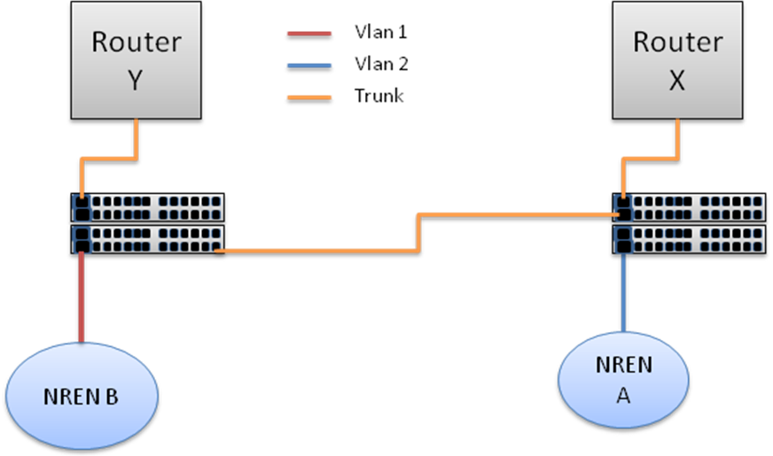
The requirements for this scenario are that the links from the NRENs or ITNs must be connected to the switches (only works with GbE Interfaces). All other configurations are logically implemented.

    - NRENs access backup sample

The Chilean network called REUNA has a 1 Gbps connection to RedCLARA. This connection will be protected by a local ring, nevertheless the peerings need to be protected in case a mayor failure in the layer-3 equipment occurs. In the following lines is described the plan to enable an alternate peering to Sao Paulo’s PoP, that would be enable in case of a disaster on the main router. First, the following figure describes the current connectivity of REUNA to RedCLARA:

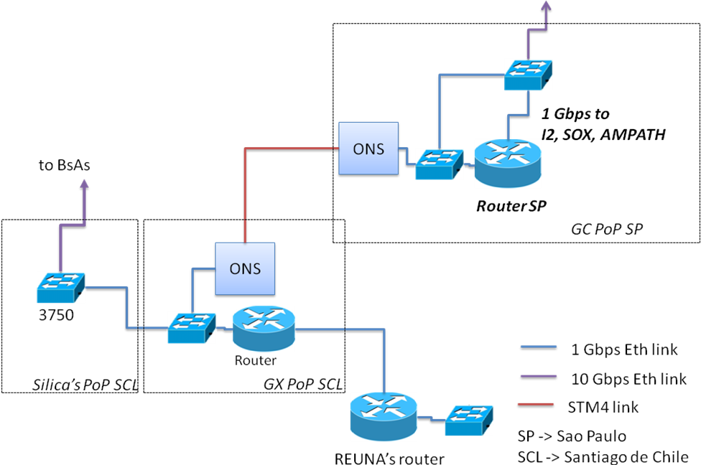

As is shown in the figure, the access of the NREN is arriving at a layer-3 equipment. The main peering is done to the RedCLARA’s router at Global Crossing’s (GX) PoP. The following figure describes the planned backup to avoid outages due to router problems:

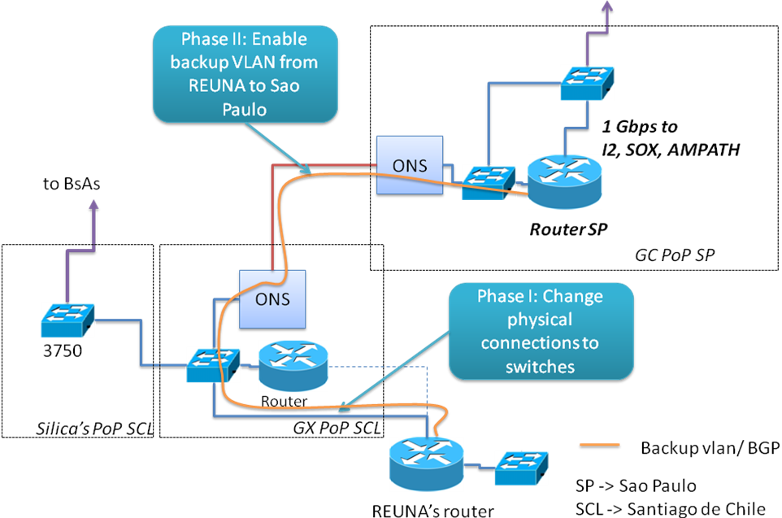

The above figure shows how the Ethernet connection would be changed to the switch in GX PoP, and the additional peering to established between REUNA and the Sao Paulo’s router. In order to achieve this, the following tasks shall be completed:

- Configure a new port at the switch with a VlanID.
- Allow this Vlan at the trunks.
- Move the cable from the router to the switch interface.
- Configure a new Sub-Interface at the backup router
- Configure all the BGP information’s.

    - Commodity backup sample

The commodity service today is provide by two different enterprises: Ampath and Terremark. This service allows RedCLARA to publish lots of services through the internet to the R&D community. The biggest issue is that both connections arrive at the same router at Miami. To cover this problem the same model can be adopted. The figure bellow describes the actual connections :
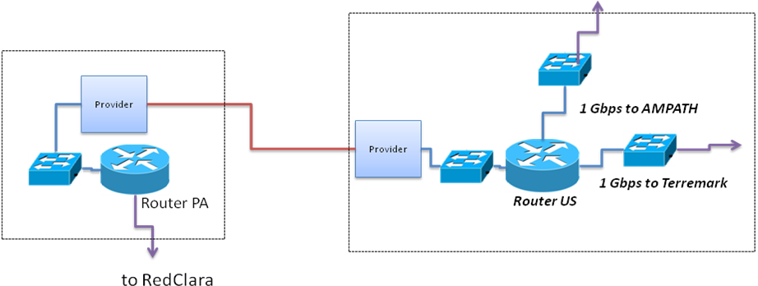
As is shown in the figure, the access of the commodity providers are arriving at a layer-3 equipment. The main peering is done to the RedCLARA’s router at Miami PoP. The following figure describes the planned backup to avoid outages due to router problems:

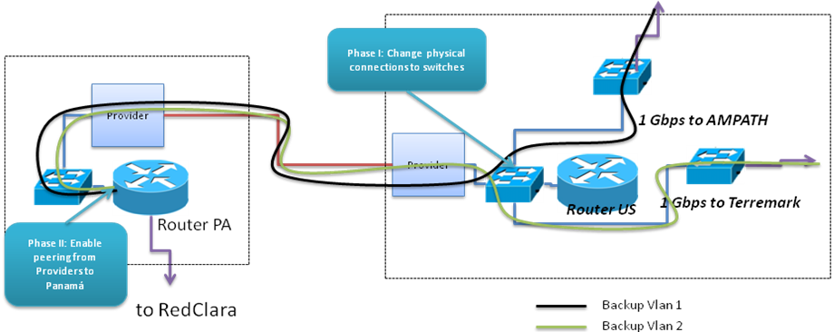

In order to achieve this, the following tasks shall be completed:

- Configure a new port at the switch as Trunk.
- Allow the commodity VlanID at the trunks.
- Move the cable from the router to the switch interface.
- Configure a new Sub-Interface at the backup router
- Configure all the BGP information’s.

  - Switch redundancy
If for some reason, a switch stops working and it is observed that will take too long to repair the problem some measures must be taken to restore the service supported by it as soon as possible. As part of the implementations of Alice2 project, all POPs now have a stacked switch. This solution was adopted so if one equipment fail all the connections can be migrated to the second unit and the service can be restored. It is mandatory to have at least one unit available at each POP.
  - Backup interface
If some router or switch presents an interface failure the NOC has run tests to identify if the problem is related to the SFP/XFP or if the interface card itself is broken.
With simple tests like switching the SFP/XFP to a new interface card this diagnosis can be done. With this diagnosis the NOC can start a procedure to replace the broken SFP/XFP or the interface card.The need of spare parts available is very important to this task and the NEG must communicate the Technical Manager about this need. If for some reason there are no spare parts available the tests can’t be done.

  - Backbone Link redundancy
It is possible that some backbone links become unavailable, to be able to cover this situation the network was planned to work with a mesh scenario. This scenario allows RedCLARA to keep NRENs connected to other NRENs and research and educations networks even in case of a backbone link present failure. The picture bellow shows the current network topology.

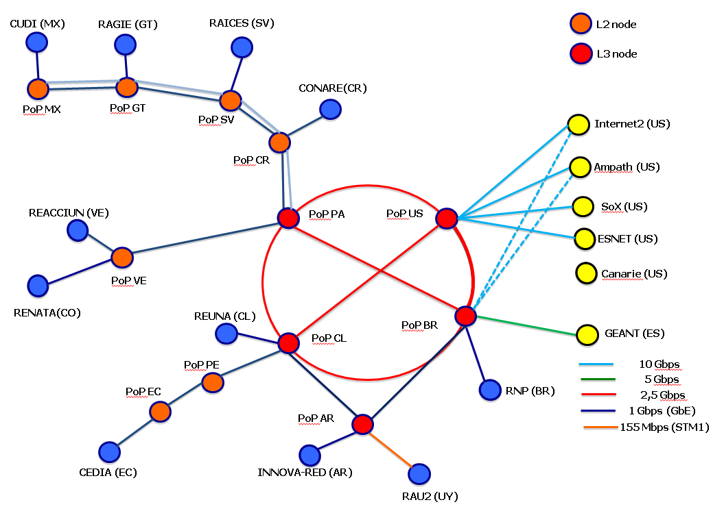

All the routing is done dynamically so in case of a failure the routers will recalculate the routes and the final client won’t be drastically affected.
To accompany this type of problem RedCLARA has a 24/7 NOC that monitors the entire network and is in charge of opening tickets and following the resolution with the providers.

  - Nren access Link monitoring

It is possible that some NRENs access links become unavailable, to be able to cover this situation RedCLARA has a 24/7 NOC that monitors the entire network and has all the network diagrams so every connection can be checked with it specific provider. This monitoring is done by automated and redundant tools.

  - Redundant ITN peering

It is possible that some links present CRC and become unavailable, to be able to cover this situation the network was planned to work with multihoming. The multihoming will allow RedCLARA to keep connected to other research and educations networks even if the main circuit gets unavailable. The picture bellow demonstrates the multihoming scenario.

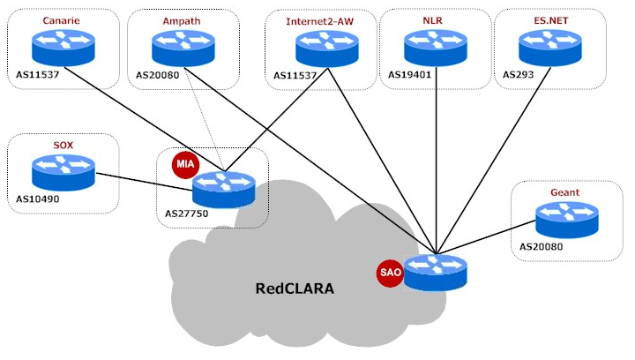
As just one link is available to Geant RedCLARA has an agreement with Internet2 that allows the transport of its networks in case of a link outage. All the routes from Geant come from Geant and Internet2 peering, making the network very resilient.

  - CPU monitoring

It is possible that some equipment present CPU increment, to be able to cover this situation RedCLARA has a 24/7 NOC that monitors the entire network and has set alarms on all equipment.
This activity depends of person intervention as the problems can have different sources. With the 24/7 RedCLARA is able to realize the problems in their initiation and active the NEG to understand what is the source of the issue.

- Preventive measures for avoiding or minimize failures
The preventive measures are all the pre issue tasks that RedCLARA has already taken or need to prevent or minimize the failures. These tasks involve lots of planning and coordination.

  - Spare parts
RedCLARA plans to have the most ordinary spare parts available at every POP. With this measure the exchange of SFPs/XFP and interface cards minimize the downtime of the service.
The following table will demonstrate the need of gear by POP.

 | Cisco 3750
Brazil | 2
Chile | 2
Panama | 1
United States | 1
Argentina | 1
Ecuador
Peru
Ecuador
El Salvador
Mexico
Office

  - Network backup routes
RedCLARA have more than one exit to the ITNs connectors. This measure was adopted thinking that one link could have problems. To exchange the traffic to the backup routes dynamical protocols are used.

  - Vlans
RedCLARA have a Vlan planning so every link installed have a different VLAN. This solution had to be adopted so the bypass described in the iten 6.1 could be done in every link.

  - Writing of procedures for recovery
RedCLARA NEG creates several recovery procedures, as the problems are being notice. This documentation serves as a knowledge database for future use. All the documentations intents to show a solution or describe the topology of the network so every operator, engineer can be aware of the actual structure.

- Recommendations and conclusions
  - Miami Router Change
As RedCLARA started selling internet commodity to its associates, the demand of use to CLARA-US raised placing the router on its limit as it only possess 1G RAM, the upgrade can’t be made as there are no better controllers to the 7600 v1 router. The NEG quoted a solution and an used ASR9006 could be bought with 30K usd (used).

  - Argentina Router Change
The cisco 12k that support this POP was acquired when the network was first deployed in 2004 and now has just one controller as the other failed, this equipment is already obsolete and cannot be upgraded, Cisco has already declared the End-of-Life for this product.

  - Topology Change
Over the last two years, the NEG evaluated the use of the 3750 switches as the core of RedCLARA network and how they worked on the present schema.
After a long period of observation and the demanding capacity grow, the NEG recommends a new schema for the backbone topology; this recommendation would be the use of a single equipment able to handle L2 and L3 services.

•The topology using layers L2 and L3 on different equipment will not be cost effective and will elevate the maintenance costs.
•With more equipment’s on each POP more space is required making administration of space worse.
•With some 100G projects arriving the equipment’s needed to handle this capacity will have elevated costs to just do L2 service.
•The topology using dedicated L2 and L3 equipment’s has shown to be more complicated in terms of administration and operation.
•The switches 3750 presented several issues of freezing .
•The switches 3750 does not have good buffers for huge data transfers.

To see how other networks handled this capacity grow the NEG talked to other NREN’s/Connectors to see how they handle this issue and what topology they are using:
Internet2 – Uses dedicated equipment to L2 and L3, an now shows the intent to use a single L2/L3 equipment
Geant – Uses a single L2/L3 equipment.
EsNET – Uses a single L2/L3 equipment.
RNP – Uses a single L2/L3 equipment.
To evaluate costs with the use of switches, the NEG requested some quotes for 40Gbps and 100Gbps gear, and the results were that the equipment’s that support this capacity are almost equal to ASRs performance.
With that in hand it is possible to demonstrate that the costs would be bigger and the benefits almost null.

The NEG points that the services demanded by the actual backbone can be used with both topologies.

It’ possible to keep using switches for L2 POP’s like Venezuela and Ecuador, that does not possess redundant routes. The use of switches are well suited and work fine (taking in consideration the lower capacity) for places where no L3 service are obligatory.

With this change the vlan extension won’t work in case of a router failure but the NEG is secure that instead of using a cheap equipment as the core of the network is worth moving the link to the routers and guarantee its correct operation.

Annex A

The following table describe the MTBF from the equipment’s present in the network :

Equipment | MTBF Hours | Operation Start | Fail Probability
Miami's router Cisco 7600 | 448,000 h | 2007 | Low/Medium
Cisco ASR Panama, Santiago, Sao Paulo | 500,000 h | 2011 | Very Low
Cisco GSR 12006 (Buenos Aires) | 276,062 h | 2005 | Medium/High
Catalyst 3750 (Santiago, Sao Paulo, Panama, | 177.954 | 2011 | Low
SFPs | 150,000 h | 2007 | Medium

Sources :
Cisco 7600 : http://www.cisco.com/en/US/prod/collateral/routers/ps368/ps367/product_data_sheet0900aecd8057f3d2.html
Cisco ASR : http://www.cisco.com/en/US/docs/routers/asr9000/software/getting_started/configuration/guide/asr9kover.html
Cisco 12006: http://www.cisco.com/en/US/prod/collateral/routers/ps167/product_data_sheet0900aecd8027c8dd_ps6342_Products_Data_Sheet.html
Cisco 7200 : http://www.cisco.com/en/US/products/hw/cable/ps2217/products_white_paper09186a00801af388.shtml
Catalyst 3750 :
http://www.cisco.com/en/US/prod/collateral/switches/ps5718/ps5023/product_data_sheet0900aecd80371991.html
SFPs : http://www.cisco.com/en/US/prod/collateral/modules/ps5455/ps6578/product_data_sheet0900aecd801ba88e.html

