

 |  | 
A project of the @LISII Programme | This project is funded by the European Union | A project implemented by CLARA
European Union’s
@LIS II Programme for Latin America

ALICE2 Project

CLARA-TEC Meeting Minutes Second Semester



Periodical Progress Report

ALICE2 Deliverable: DO1.6-13 CLARA-TEC Meeting Minutes Second Semester v1.0

Document Full Name | ALICE2-DO1.6-13 CLARA-TEC Meeting Minutes Second Semester v1.0
Date | 12/26/2011
Activity | 1.6 Operation of the Network and Engineering Activities
Lead Partner | RNP
Document status | DRAFT
Classification Attribute | Internal to Project Partners
Document link

Abstract. The second CLARA-TEC meeting of the year 2011 was carried out in Montevideo/Uruguay. This document contains the minutes of this encounter that covered the report of the technical management activities, presentations of security providers and updates of the RedCLARA’s technical working groups.

Copyright notice
Copyright © Members of the ALICE2 Project, November 2011
ALICE2 (América Latina Interconectada con Europa 2 – Action Name: Extending and Strengthening RedCLARA as e-Infrastructure for Collaborative Research and Support to Development) is a project co-funded by the European Commission within the @LIS II Programme. ALICE2 began on 1st December 2008 and will run for 45 months.
For more information on ALICE2, its partners and contributors please see (after March 29th, 2009) http://alice2.redclara.net.
You are permitted to copy and distribute, for non-profit purposes, verbatim copies of this document containing this copyright notice. This includes the right to copy this document in whole or in part, but without modification, into other documents if you attach the following reference to the copied elements: “Copyright © Members of the ALICE2 Project, 2008. See http://alice2.redclara.net for details”.
Using this document in a way and/or for purposes not foreseen in the paragraph above, requires the prior written permission of the copyright holders.
The information contained in this document represents the views of the copyright holders as of the date such views were published.
THE INFORMATION CONTAINED IN THIS DOCUMENT IS PROVIDED BY THE COPYRIGHT HOLDERS “AS IT IS” AND ANY EXPRESSED OR IMPLIED WARRANTIES, INCLUDING, BUT NOT LIMITED TO, THE IMPLIED WARRANTIES OF MERCHANTABILITY AND FITNESS FOR A PARTICULAR PURPOSE ARE DISCLAIMED. IN NO EVENT SHALL THE MEMBERS OF THE ALICE2 COLLABORATION, INCLUDING THE COPYRIGHT HOLDERS, OR THE EUROPEAN COMMISSION BE LIABLE FOR ANY DIRECT, INDIRECT, INCIDENTAL, SPECIAL, EXEMPLARY, OR CONSEQUENTIAL DAMAGES (INCLUDING, BUT NOT LIMITED TO, PROCUREMENT OF SUBSTITUTE GOODS OR SERVICES; LOSS OF USE, DATA, OR PROFITS; OR BUSINESS INTERRUPTION) HOWEVER CAUSED AND ON ANY THEORY OF LIABILITY, WHETHER IN CONTRACT, STRICT LIABILITY, OR TORT (INCLUDING NEGLIGENCE OR OTHERWISE) ARISING IN ANY WAY OUT OF THE USE OF THE INFORMATION CONTAINED IN THIS DOCUMENT, EVEN IF ADVISED OF THE POSSIBILITY OF SUCH DAMAGE.

DELIVERABLE ROUTE
 |  | Name |  | Member/Activity |  |  | Date | Responsible
From |  | Gustavo Garcia |  | CLARA /Technical Manager |  |  | 26/12/2011 | Gustavo García, NEG
Revised by
Revised by
Revised by
Revised by
Revised by
Approved by
DOCUMENT DESCRIPTION
Subject | Date |  | Comment |  |  | Author
0-0 | 26/12/2011 |  | CLARA-TEC Meeting Minutes |  |  | Gustavo Garcia
REGISTER OF CHANGES
Subject | Item |  |  |  | Reason for Change

TABLE OF CONTENTS
Content
Periodical Progress Report 1
ALICE2 Deliverable: DO1.6-13 CLARA-TEC Meeting Minutes Second Semester v1.0 1
Copyright notice 2
INTRODUCTION 5
GLOSSARY 5
CLARA-TEC MINUTES 6
Monday, November 7: 6
RAU2 - Luis Castillo 6
EduGAIN and EduPERT towards Latin-America (Tom Fryer, Valter North, Bartek Gajda) 6
RedCLARA’s Technical Management and Project status (Gustavo Garcia) 8
Global Lambda Integrated Facility GLIF (Leandro N. Ciuffo RNP/Brazil) 10
MCONF working group (Valter): 12
IPv6 working group (Azael Fernandez UNAM/CUDI/Mexico) 13
Mobility working group (Jose Luis Quiroz/RAAP) 14
VoIP Inter-exchange point in RedCLARA (Alex Galheano RNP/Brazil PIT VoIP project leader) 15
Tuesday November 8 17
Introduction to RedCLARA’s web services (Carlos Gonzalez RedCLARA’s software development leader) 17
Measurements working group (Jose Suruagy RNP/Brazil, working group coordinator) 18
GT-MOF (Leandro Bertholdo RNP/Brazil, working group coordinator) 19
IPTV working group (Jaime Martinez UNICAUCA/RENATA/Colombia) 20
GT-SCIFI (Luiz Claudio Schara Magalhães/RNP Brazil/Group’s coordinator) 21
ISOC (Cristian O’ Laferty, Carolina) 22
Evolution of Network Access (CONATEL, Gerardo Leroy) 24
Identity Management (Roberto Gallo, Kryptus/Brazil) 24

INTRODUCTION

RedCLARA carried out its second CLARA-TEC meeting of the year in Montevideo/Uruguay. In this meeting, the RedCLARA’s teams, communities and some external organizations performed presentations to update and provide information of advances in different fields. The technical management team provided and update of the network, GEANT presented services like EduCONF, and the EduPERT, the RedCLARA’s working groups’ coordinators provided updates of their plans and external organizations like ISOC, KRYPTUS provided information about their organizations and technologies. The Uruguayan Academic Network (RAU) was the host of this event developed in the Four Points hotel in Montevideo.

GLOSSARY
The conventions used in this document are:

AA: Authentication and Authorization
ADSIB: Agency for Information Society of Bolivia
CEDIA: NREN from Ecuador.
CUDI: NREN from Mexico.
EduPERT: GEANT’s Performance Enhancement Response Team (PERT) service
EduGAIN: GEANT’s Authentication and Authorization (AA) federations service
GEANT: pan-European Advance Network.
INNOVARED: NREN from Argentina.
ITAIPU: NREN initiative from Paraguay.
LACNIC: Latin-American and Caribbean Addresses Registry
NREN: National Research and Education Network.
RAGIE: NREN from Guatemala.
RAICES: NREN from El Salvador.
RAAP: NREN from Peru.
RAU: NREN from Uruguay.
REACCIUN: NREN from Venezuela.
RENATA: NREN from Colombia.
REUNA: NREN from Chile.
RNP: NREN from Brazil.
UNAM: National Autonomous University of Mexico
UNA: National University of Asunción, Paraguay
IRU: Irrevocable Right of Use.

CLARA-TEC MINUTES

Monday, November 7:

RAU2 - Luis Castillo

Luis Castillo, RAU’s technical manager, presented a summary of the Red Academica Uruguaya (RAU)'s projects. First, he mentioned the network expansion that includes 110 academic nodes. 50 nodes are distributed across the country (92 fiber km), and 60 nodes (103 fiber km) in the Montevideo. The infrastructure to be used includes a concentration node in the North, and another in Montevideo.

The network will provide 45% lower costs, and growing by 75% of the network’s capacity. The total investment will be 6 Million dollars. Brazil is supporting the project and there are funds created for it.

Audience questions:

Q: Iara Machado (RNP/Brazil) asked, what is the status of the project?
A: Luis mentioned that the project is presented and waiting for approval. In Brazil, the initiative is created, and there some funding organizations involved.
Q: Sandra Jaque (REUNA/Chile) asked if they include an agreement for network growing.
A: Luis answered that they are working on it, and that they will take into account.
Q: Sandra asked if the project includes only routing equipment and what is the project’s timeline?
A: Luis answered that only routing, and the timeline is a year.
Q: Has Reyes (CUDI/Mexico) asked if ANTEL is the only provider?
A: Luis answered that there are about three providers with the required capacity.

EduGAIN and EduPERT towards Latin-America (Tom Fryer, Valter North, Bartek Gajda)

Tom Fryer, and Valter North from GEANT, carried out the presentation of the GEANT's EduPERT and EduGAIN services. Tom started by a brief summary of the GEANT's services.
They started by the definition of the PERT (Performance Enhancement Response Team). Tom mentioned is a virtual organization that helps to improve or troubleshoot performance issues.
Benefits of EduPERT
- Access to knowledge of experienced and qualified engineers.
- Access to advice about TCP/IP protocols, network topology, status and history.
- Access to private contact details of accredited PERTs.
- Accredited PERTS can request specific technical information, from other PERTs.
- EduPERT is a simple and unconstrained resource that maximizes creativity and performance.
EduPERT central services:
- Registration and accreditation
- Arranging EduPERT meetings
- Running Knowledge base
- Maintaining directory of EduPERTs.

Audience questions:
Iara Machado (RNP/Brazil) asked how the certification process is, and who can request EduPERT’s services?

EduGAIN:

Tom began with showing the definition of EduGAIN: An enabling infrastructure that interconnects the national research & education identity federations. EduGAIN is also a legal technology framework that groups thousands of organizations and millions of users.
Advantages of EduGAIN:

- Large number of users available
- Only authorized users can access the services.
- Lower costs and increased security
By now, there are 11 identity federations, and the project started in April 2011.

Audience questions:

Q: Antonio mentioned that RNP is applying to get access to EduGAIN, but they have a doubt if TACAR (Terena CA service) federation service of if they will be integrated.
A: Answer pending.

Q: Iara Machado (RNP/Brazil) asked what is the relation of EduGAIN with ReFEDs?
A: Valter answered that ReFEDs is a community discussion the service, and EdUGAIN is the service itself.

Q: Alejandro Lara asked how they integrate the different systems in Europe, due to some of them use Shibboleth and others use different technologies.
A: Valter answered they only connect some of them. The Spain network for instance, is working in how to integrate with EduGAIN.

Q: Antonio Nunez (RNP/Brazil) asked how works the relationship with the providers. It is necessary to make agreements with the service providers, or if this is handled by the providers?
A: Valter mentioned that depends of the kind of service or relationship to be established. In case to be a publisher, they would need a separated agreement.
Iara Machado (RNP/Brazil) suggested that RedCLARA's portal to work with Shibboleth.

RedCLARA’s Technical Management and Project status (Gustavo Garcia)

Gustavo Garcia, RedCLARA’s technical manager, stated with a summary of the network status up to November 2011. The following figure shows the current network to this date:

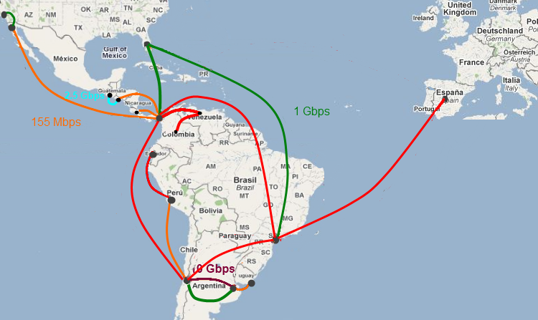
Figure no. 1. RedCLARA’s network topology November 2011

Gustavo followed with a summary of the links’ activations carried out in 2011. The summary is presented in the following table:

Link | Capacity | Activation date
Santiago de Chile – Panama City | STM-4 | July 6/2011
Sao Paulo – Panama City | STM-4 | September 6/2011
Santiago de Chile – Sao Paulo | STM-4 | September 6/2011
Guayaquil – Lima | 622 Mbps (GEth) | October 3/2011
Bogota – Caracas | 622 Mbps (GEth) | October 28/2011
Caracas – Panama City | 622 Mbps (GEth) | October 28/2011

Gustavo’s presentation continued with a summary of the equipment’s installation activities. Gustavo mentioned especially the activation of the new Caracas’ PoP.

Gustavo’s presentation also showed a summary of the tender procedures, and the Network Engineering Group (NEG)’s activities. On Tender procedures, he mentioned the adjudications of Caracas-Panama link in January, Lima (Peru)-Antofagasta (Chile) on February, and the dark fiber for Central America on May. Regarding NEG activities, Gustavo explained the NEG’s work on:

- Tender procedures support and evaluation (Central Americas’ equipments mainly)
- Circuit provisioning service concept
- Disaster recovery plan for the network
- Pending links’ implementations

Gustavo continued with a summary of the Systems Engineering Group (SEG), and the software development’s work. He mentioned actions like: a) the development if a “Systems Security plan”, b) the deployments of the systems for Integrated Video-conference Service (SIVIC) version 2, c) the new portal services for photo sharing, video publications, Compendium The presentation continued with a description of the Circuit Provisioning Service (CPS) work plan. The work plan divided the CPS in three phases: Phase I: Offline service implementation (testing environment), Phase II: Service implementation in RedCLARA’s backbone, and Phase III: Implementation at NRENs’ level.
Version 2, and the unified reports systems for RedCLARA.

Gustavo ended with a description of the network operations' events. Gustavo Highlighted some problems in the Buenos Aires to Santiago de Chile’s trunk, and he mentioned that they are been solved through the change of an equipment in Santiago’s pop.

Questions from the audience:

Q: Luis Castillo requested to add the delay verification to the technical agenda. He said that there are institutions saying the delay is better through commercial Internet. Andres, Sandra and Luis ask to carry out a work with the NRENs in order to detect possible network issues or thing for improvement.

A: Gustavo mentioned that this work will be carried out with the NRENs.

Q: Genghis Rios suggested a link in the bottom of RedCLARA’s page, in order to report possible problems with the site. Genghis said that some people do not know the procedure to report these cases.
A: Gustavo mentioned that they will work on this.
Q: Andres Salinas suggested reviewing the way to access the services. He mentioned that and Interface oriented to Web2.0 icons could be more intuitive. Sandra Jaque and Andres Salinas mentioned that there is some work with RSS.
A: Gustavo answered that RedCLARA will have it into account for future designs.

Global Lambda Integrated Facility GLIF (Leandro N. Ciuffo RNP/Brazil)
Leandro presented the GLIF project. He mentioned various applications like:
- FEI Remote Microscope demo at IMC-17. Rio de Janeiro – Eindhoven
- CineGrid that uses the circuit service to exchange very-high-quality digital media. They carried out a premiere of a 4K resolution movie (750 MB/seg 30 MB/frames x 24 fps) and 5.1 audio.
The Leandro’s presentation also showed a summary of the last GLIF2011 annual workshop. The event counted with the following people amount participations:

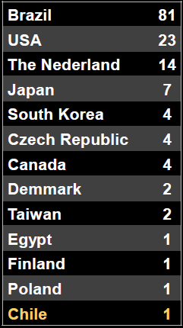

Leandro also mentioned the circuit provisioning demos carried out during the event. One of the circuits was between Sao Paulo and Caltech in California.

Security’s working group (Liliana Velasquez Sonha, RNP/Brazil)

Liliana Velasquez Sonha, Security’s working group coordinator, carried out the presentation about the group. Liliana provided a brief of the security situation, highlighting the lack of tools to monitor the security situation in LA. She mentioned the tool Surf IDS, as a leading application for distributed Intrusion Detection System (D-IDS).
Liliana showed how the system works with HoneyPots. The HoneyPots are small systems on each NREN meant to capture malicious activity.
Liliana also showed their plans for incident treatment. One of the strategies is to use incident sources like shadow-server, zone-h, spamcop, agreements, etc.
CAIS generated a tool called Genics, and Liliana presented its architecture description. The GENICS’ two goals are contact management, and incident management.
At the end of her presentation, Liliana showed a slide with a summary of the group’s plan:

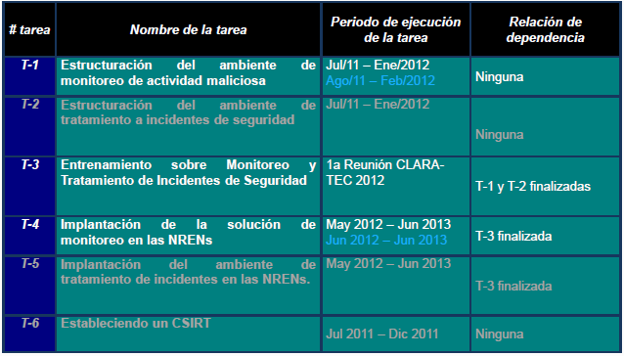

Questions from the audience:

Q: Sandra Jaque (REUNA/Chile) asked what analysis tools were to be used?
A: Liliana answered there is a page to check the amount of malware and any threads captured by the system.

MCONF working group (Valter):

Valter started its presentation of the group with the goal: providing a webconference system that allows connection with mobile devices.
Valter carried out a demonstration with users in different locations. They modified the BBB with a video dock that allows increasing or reducing screen size. They also added a shared notes block.
Valter presented the project status. The VM required for the server testing was installed by Oct/11.
Valter mentioned the code was in:

http://code.google.com/p/mconf/wiki/MconfVM

Valter also showed the statistics of the server. The amount of conferences by day, week, and he stated that they will include server statistics like cpu, memory, etc. Valter showed that the system is already integrated with the Cafe (Federation authentication service from Brazil).

Questions from the audience:

Q: Iara Machado (RNP/Brazil) asked how we are going to involve all the NRENs in the process?
A: Valter mentioned NRENs like RENATA that are already involved and installing the system.

Q: Gustavo Garcia (RedCLARA’s technical manager) asked if the system can be extended to support more Webconference users.
A: Valter answered that for the moment there are another priorities in areas like usability, but they will have it in mind.

Q: Antonio Fernandez (RNP/Brazil services director) asked about how was the experience of MCONF in a virtualized environment?
A: Valter answered that good but for a production environment they always recommend a dedicated machine.

Q: Antonio Fernandez (RNP/Brazil services director) asked about how they are going to handle in low bandwidth environment, taking into account there are some institutions with very low bandwidth.
A: Valter answered that the system works with low bandwidth resources.

IPv6 working group (Azael Fernandez UNAM/CUDI/Mexico)

Azael presented the Ipv6 working group. He started by an overview of the working group’s goals, highlighting that this time. The goal is to extend the Ipv6 to the NREN client institutions. The tasks are:
- Current situation analysis
- Planning and design Ipv6 schemes phase I
- Planning and design Ipv6 schemes phase II
- Planning and design IPv6 schemes phase III
- Deployment and implementation of IPv6
- Web services IPv6 enabled
- DNS services IPv6 enabled
- RedCLARA’s IPv6 day

Azael provided the following links with the information about IPv6 on the region:
http://tunnelbroker.ipv6.unam.mx:8080/ipv6-RedCLARA/estado.html
http://wiki-gtipv6.reuna.cl
http://ipv6.redclara.net

Azael showed the survey that would be sent to the institutions in order to have the inventory of the Ipv6 resources, and information about the institutions.
The work plan also has the example templates (good practice manuals) that will contain information about the last group’s work.

Mobility working group (Jose Luis Quiroz/RAAP)

Jose Luis highlighted the participation growing of NRENs in the group. The following NRENs have joined to the group: RAICES, CONARE, REACCIUN, RENATA, CEDIA, REUNA, RAU, INNOVARED.
The working group’s goal is to apply mobile technologies and network middleware to provide services in secure RedCLARA environments. Some specific goals:
- Consolidate the EduROAM service in LA
- Elaborate workshops
- Deploy procedures that allow the implementation of EduROAM in LA
- Deploy documentation of use policies
- Implement and explore new services like
- Explore RadSec, DNSSEC, secure procedures
- Other alternatives

Jose Luis showed the following map with the participant countries:
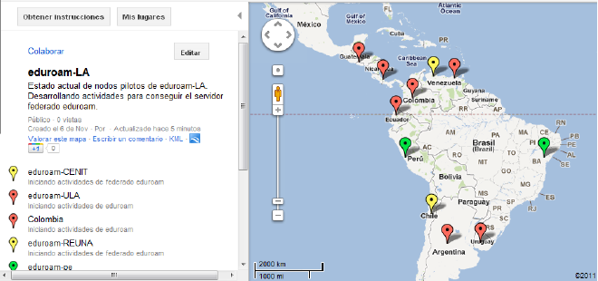

Jose Luis listed the tasks of the group, mentioned that REUNA already implemented its EduROAM’s service.
Jose Luis mentioned that it is pending to deploy and publish a web site for the EduROAM service, requirement to be recognized as EduROAM’s nodes in LA.

Audience questions:

Q: Iara Machado (RNP/Brazil) asked who handles the confederation?
A: Jose Luis mentioned that there is a governance board that defines the guidelines, but every federation has to peer with all the others.

NOTE: Antonio Carlos mentioned that Brazil is going to implement a EduROAM service by 2012. Antonio requested to Jose Luis a talk about it.

Q: Jose Luis asked for some thoughts and opinions about the EduROAM’s training.
A: Alejandro from REUNA mentioned that it is good, a little tied the material, but he congratulated to Jose Luis. Erick Flores also said good comments, and an opinion about the forum, that it could be improved.

VoIP Inter-exchange point in RedCLARA (Alex Galheano RNP/Brazil PIT VoIP project leader)

As the leader of the deployment of a VoIP Inter-exchange point (IXP), Alex Galheano carried out the presentation of the VoIP project for RedCLARA. The main idea behind this project is to make RedCLARA the central VoIP exchange point for Latin-America. With this project, the countries’ institutions and NRENs will not have to implement individual peering between all institutions (would be a lot of them). Instead, the communication model will be as in the following graph:

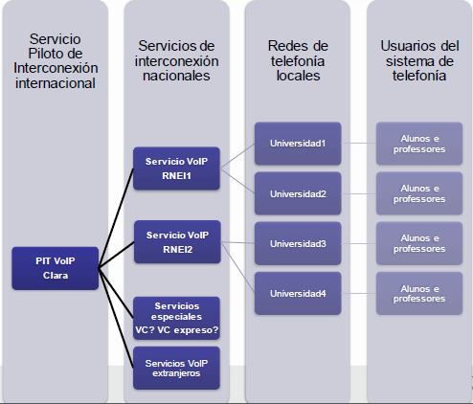

Alex started with the groups goals:
- Model and implement a VoIP exchange point in RedCLARA
- Specification of the required dissemination activities
He followed by with an explanation of the work methodology summarized as:
- Two presence meetings
- One virtual meeting per month
- Virtual meetings on demand
- Documentation and the Wiki
- Interaction using the email system.

Alex showed the main window of the PTT VoIP application. The application showed the call statistics, and metrics like CPU, and memory from the server. Furthermore, he displayed the call routing configuration window.
Alex mentioned they are working in the policies and characteristics definition. He request to the audience to go to the Wiki and provide comments about it.

Audience questions:

Q: Carlos Gonzalez (RedCLARA software development leader) asked if they think that the regulation in the countries could be an entry barrier.
A: Alex mentioned that the idea is not to allowing calls to the public telephone network (PSTN). The above shall avoid any regulation issues due to it will work as a call on the Internet only.

Q: Gustavo Garcia (RedCLARA’s technical manager) asked how the support and the monitoring is performed in RNP.
A: Alex mentioned that the monitoring and support are carried out by NOC and an information technology (IT) group. The NOC will request support to the IT team, in case they see the alarms in monitoring, and the reports from users are received through the IT group. The service is delivered on business hours only.

Tuesday November 8

Introduction to RedCLARA’s web services (Carlos Gonzalez RedCLARA’s software development leader)

Carlos Gonzalez developed the presentation about the RedCLARA’s portal and its services. Carlos started by mentioning the services implemented in 2011, first and second semester. The following table provides this summary:

Services 1 semester 2011 | Services 2 semester 2011
- Communities manager  - Integrated Video conference services (SIVIC) V1  - VC Espresso (Web-conference services)  - Funds alerts database  - Partners search  - Academic events manager (Indico) | - Integrated Video-conference (SIVIC) V1.2  - Video publication services  - Content (web) publication services  - Compendium 2011  - Unified reports system

Carlos followed with slides of services’ screens, as the following of the communities’ portal:

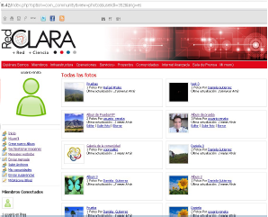

Carlos presentation ended with a demonstration of the portal services, and the explanation of the training activities carried out for the communities.

Audience questions:

Q: Iara Machado (RNP/Brazil) asked if the space for the groups could be distributed differently on the Web page, she mention that it seems difficult for her to find some services.
A: Carlos answered that all the services can be accessed through the top menu, and he will transmit the comments to the design group.

Measurements working group (Jose Suruagy RNP/Brazil, working group coordinator)

Jose Suruagy presented the measurements working group. He explained the goals to implement Perfsonar nodes in all RedCLARA’s nodes, and after in the NRENs.

Jose told how the Perfsonar group has synergies with the GISELA project. Jose mentioned the tasks of the group including the deployment and test with the new version “Perfsonar MDM”.
Jose told that the last Perfsonar version is 3.3 and the RedHat RPM packages are ready, Debian packages would be in approximately 3 weeks.

The modules suggested for the implementation are:
- HADES MP (90 packets every minute)
- BWCTL MP (tests every 6 hours)

The requirements for PoP are: (2) machines and a GPS system. Jose mentioned that it is required to be dedicated machines.

The deadline for the MDM implementation is March 2012, the work is divided in the following steps:
- Dedicated MPMs at the NREN border
- MPs at NREN main PoPs

Audience questions:

Q: Iara Machado (RNP/Brazil) asked if the points that have Perfsonar toolkit version, would need a different machine to install the new version Perfsonar MDM?
A: Jose answered that they require a dedicated machine.

Q: Iara Machado (RNP/Brazil) asked to the audience what NRENs will be interested in the installation of Perfsonar MDM.
A: All the NRENs showed interest in participate.

NOTE: Tom Fryer commented that GEANT and Internet2 have accomplished the inter-operability between Perfsonar MDM and Perfsonar Toolkit.

GT-MOF (Leandro Bertholdo RNP/Brazil, working group coordinator)

Leandro explained the goal of the Mobility with Openflow (MOF) working group. Leandro started with the description of the Openflow technology. Openflow separates the controller plane from the data forwarding plane, what gives advantages in cost, flexibility and operation. He explained the concept of flow aggregation, what makes easier to store the flow information (one line per various flows). Openflow has two ways of work, reactive or proactive. In the first case, the flow routing is consulted each time, in the second there is predefined flow information uploaded.

He use Open vSwitch that is an open source switch deployed in software. FlowVisor is an open-source tool to check how it is distributed the network. Controllers: NOX (more active), Beacon, Trema, Maestro, ONIX. Applications: ENVI (GUI).

Openflow is not a production quality system yet.

Leandro explained how they worked with a demonstration with the Mininet software. Mininet is a platform to simulate virtualization with Openflow.

The main problems are:
- Lack of documentation
- Phyton issues
- Debugging is not simple
- Mininet has some issues yet

IPTV working group (Jaime Martinez UNICAUCA/RENATA/Colombia)

Jaime started its presentation showed a conceptual diagram of the IPTV solution for RedCLARA. He mentioned the production quality status and the URL in the platform in:
http://190.69.2.16/iptv-multicanal

The platform aims to connect content from different NRENs into a single IPTV channel. The content is recorded, but very soon could be real time re-transmission of the content. Jaime showed the architecture with the following figure:

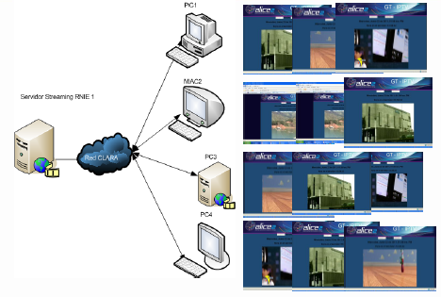

Jaime mentioned the goal to integrate the grill and transmission modules. The system is multichannel, and today supports 3.
In its presentation, Jaime showed how to program the grills on different channels.
Jaime mentioned the courses carried out through the system:
- RENATA more than 100 participants
- CEDIA more than 40

Jaime told they have transmissions using DVTS, and they have the challenge to have all the NRENs transmitting on the platform.

Q: Is posible that multiple users to administer the programming grid with permissions per user?
A: Jaime answered that there shall be one administrator per institution.

GT-SCIFI (Luiz Claudio Schara Magalhães/RNP Brazil/Group’s coordinator)

Luis started his presentation by explaining the motivation of the group’s scope of work:

Due to the growing on WiFi access, the performance has become unsatisfactory because of Interference, and uneven load distribution.

The goal of the group is to make wireless service, easier to install, use and manage by doing:

- Channel selection
- Power control
- Load distribution

Luis showed a demonstration of the administration tools they are working on:

http://200.20.10.76:8080/ControllerWeb/admin/admin.html

The demo contained a list of the Brazilian access points. The application listed parameters like power, quality estimate, frequency used. He mentioned the installation carried out in the Fluminense Federal University (UFF) campus.

Audience questions:

No questions.

ISOC (Cristian O’ Laferty, Carolina)

Cristian’s presentation began with a description of ISOC organization. Cristian described it as a not-for-profit charitable organization. ISOC only focus is promotion the Internet, with emphasis on.
• Enabling Access
• InterNetworks
• Trust & Identity

Cristian explained the goal of ISOC to increase the participation of the region on ISOC forums and the IETF. One of their ideas is to promote the participation on these themes by increasing the points and academic rewards when they carry out activities related to it.
Cristian mentioned that he is the contact to connect people with the chapters.

Audience questions:

Q: Azael asked how the workshops are carried out: in presence or virtual?
A: Cristian answered, in person usually.

DNS authentication with PKI (Carlos Martinez, Arturo Servin)

Carlos started by describing LACNIC as organization, and provided reference pages:

http://ris.ripe.net
http://rpki.lacnic.net

Arturo explained the steps to create an RPKI validation for the organization. The first slides showed the basic requirements for RPKI:
- A router capable
- A cache system that can be implemented in Open-source
- The creation of certificate and ROA in your RIR system.

Audience questions:

Q: Sandra Jaque (REUNA/Chile) asked if the NRENs that already have a CA for the Grid could use the same infrastructure.
A: Arturo answered that there are different implementations. The ROAs are a little more than a certificate, so this infrastructure needs to be created.

Q: Leandro asked if they want to allow is blocks to enter into the table?
A: Arturo answered that if the blocks are not signed, there will.

NOTE: Carlos Mentioned that LACNIC is the second region in adopt RPKI.

Q: Gregorio asked how last a certificate?
A: Arturo answered if there is year of validation.

Arturo showed how the configuration is done in a Cisco, a Juniper and a Quaga routing system.
Q: Gregorio mentioned that they think that the RPKI will solve only the unintentional and kidnapping of AS by errors.
A: Carlos answered yes, the thing is that they worked to solve the 80% of the cases; the work starting is on validation of the path.

Evolution of Network Access (CONATEL, Gerardo Leroy)

Protecting the network border is no longer the same. The branch network has other mechanism like VPNs that.

Cisco proposed the NAC protocol; the system evaluates a machine for a required posture. Meaning that if the machine is updated, has antivirus, etc. it is allowed to enter in the network. The NAC allows to:
- Security audits
- Device assessments

The solution from Cisco to the AAA is called TrustSec with ISE, and takes the security enforcement to the border of the network.
Cisco’s solution allows implementing authentication, authorization, accounting and services.

Identity Management (Roberto Gallo, Kryptus/Brazil)

The invited provider Kryptus presented the solutions they offer for Hardware Security Modules (HSM) for certification authorities. The HSM systems can generate, store and administer certificates for a complete certification authority.

Audience questions:

Q: Manuel asked if it is posible to use OpenHSM with Kryptus’ products?
A: Roberto answered yes.

Q: Is there any RPKI solution installed outside Brazil?
A: Roberto answered that they are working with LACNIC.

