

 |  | 
A project of the @LISII Programme | This project is funded by the European Union | A project implemented by CLARA
European Union’s
@LIS II Programme for Latin America

ALICE2 Project

CLARA-TEC Meeting Minutes First Semester



Periodical Progress Report

ALICE2 Deliverable: DO1.6-12 CLARA-TEC Meeting Minutes First Semester v1.0

Document Full Name | ALICE2-DO1.6-12 CLARA-TEC Meeting Minutes First Semester v1.0
Date | 9/03/2011
Activity | 1.6 Operation of the Network and Engineering Activities
Lead Partner | RNP
Document status | DRAFT
Classification Attribute | Internal to Project Partners
Document link

Abstract. The first CLARA-TEC meeting of the year 2011 was carried out in Honduras/Tegucigalpa. This document contains the minutes of this encounter that covered the report of the technical management activities, and proposals for the new RedCLARA’s technical working groups.

Copyright notice
Copyright © Members of the ALICE2 Project, Sep 2011
ALICE2 (América Latina Interconectada con Europa 2 – Action Name: Extending and Strengthening RedCLARA as e-Infrastructure for Collaborative Research and Support to Development) is a project co-funded by the European Commission within the @LIS II Programme. ALICE2 began on 1st December 2008 and will run for 45 months.
For more information on ALICE2, its partners and contributors please see (after March 29th, 2009) http://alice2.redclara.net.
You are permitted to copy and distribute, for non-profit purposes, verbatim copies of this document containing this copyright notice. This includes the right to copy this document in whole or in part, but without modification, into other documents if you attach the following reference to the copied elements: “Copyright © Members of the ALICE2 Project, 2008. See http://alice2.redclara.net for details”.
Using this document in a way and/or for purposes not foreseen in the paragraph above, requires the prior written permission of the copyright holders.
The information contained in this document represents the views of the copyright holders as of the date such views were published.
THE INFORMATION CONTAINED IN THIS DOCUMENT IS PROVIDED BY THE COPYRIGHT HOLDERS “AS IT IS” AND ANY EXPRESSED OR IMPLIED WARRANTIES, INCLUDING, BUT NOT LIMITED TO, THE IMPLIED WARRANTIES OF MERCHANTABILITY AND FITNESS FOR A PARTICULAR PURPOSE ARE DISCLAIMED. IN NO EVENT SHALL THE MEMBERS OF THE ALICE2 COLLABORATION, INCLUDING THE COPYRIGHT HOLDERS, OR THE EUROPEAN COMMISSION BE LIABLE FOR ANY DIRECT, INDIRECT, INCIDENTAL, SPECIAL, EXEMPLARY, OR CONSEQUENTIAL DAMAGES (INCLUDING, BUT NOT LIMITED TO, PROCUREMENT OF SUBSTITUTE GOODS OR SERVICES; LOSS OF USE, DATA, OR PROFITS; OR BUSINESS INTERRUPTION) HOWEVER CAUSED AND ON ANY THEORY OF LIABILITY, WHETHER IN CONTRACT, STRICT LIABILITY, OR TORT (INCLUDING NEGLIGENCE OR OTHERWISE) ARISING IN ANY WAY OUT OF THE USE OF THE INFORMATION CONTAINED IN THIS DOCUMENT, EVEN IF ADVISED OF THE POSSIBILITY OF SUCH DAMAGE.

DELIVERABLE ROUTE
 |  | Name |  | Member/Activity |  |  | Date | Responsible
From |  | Gustavo Garcia |  | CLARA /Technical Manager |  |  | 9/03/2011 | Gustavo García, NEG
Revised by
Revised by
Revised by
Revised by
Revised by
Approved by
DOCUMENT DESCRIPTION
Subject | Date |  | Comment |  |  | Author
0-0 | 3/09/2011 |  | CLARA-TEC Meeting Minutes |  |  | Gustavo Garcia
REGISTER OF CHANGES
Subject | Item |  |  |  | Reason for Change

TABLE OF CONTENTS
Content
Periodical Progress Report 1
ALICE2 Deliverable: DO1.6-12 CLARA-TEC Meeting Minutes First Semester v1.0 1
Copyright notice 2
INTRODUCTION 6
GLOSSARY 6
CLARA-TEC MINUTES 7
THURSDAY JUN 23/2011 7
RedCLARA technical management update (presented by Gustavo Garcia): 7
RedCLARA’s portal services (Presented by Carlos Gonzalez): 10
Grid Initiatives for e-Science virtual communities in Europe and Latin America (GISELA) project update: 11
6DEPLOY: IPv6 Deployment Support Project Overview: 12
Latin-American and Caribbean Internet Addresses Registry (LACNIC), IPv6 related activities 14
Openflow @ HP: 16
RedCLARA working groups 2009-2010 evaluation: 17
GT-CSIRT (Computer Security Incident Response Team for RedCLARA): 19
GT-MOF (Mobility): 20
FRIDAY JUN 24/2011 20
GT-DEIM-IPv6 proposal for RedCLARA: 20
GT Measurements: 21
GT Mobility 22
GT IPTV 22
GT PIT VOIP (VOIP Traffic exchange point) 23
GT SCIFI 25
GT MCONF 25
TICAL Report 26
GEANT Services and Regional Projects update 27
Café (Identity Federation Service for Research and Education) 28

INTRODUCTION

The first CLARA-TEC meeting of the year, was carried out in the University José Cecilio del Valle (http://www.ujcv.edu.hn) in Tegucigalpa, Honduras. The meeting took place in June 23 and 24/2011. The meeting was focused on the presentation of the RedCLARA’s advances, the proposals for working groups, and some provider's presentations about leading technologies like Openflow, and IPv6. Other organizations like GEANT and LACNIC participate by sharing information about their services and its status.

These meeting minutes contains the main subjects treated in the meetings.

GLOSSARY
The conventions used in this document are:

ADSIB: Agency for Information Society of Bolivia
CEDIA: NREN from Ecuador.
CUDI: NREN from Mexico.
GEANT: pan-European Advance Network.
INNOVARED: NREN from Argentina.
ITAIPU: NREN initiative from Paraguay.
LACNIC: Latin-American and Caribbean Addresses Registry
NREN: National Research and Education Network.
RAGIE: NREN from Guatemala.
RAICES: NREN from El Salvador.
RAAP: NREN from Perú.
RAU: NREN from Uruguay.
REACCIUN: NREN from Venezuela.
RENATA: NREN from Colombia.
REUNA: NREN from Chile.
RNP: NREN from Brazil.
UNAM: National Autonomous University of Mexico
UNA: National University of Asunción, Paraguay
IRU: Irrevocable Right of Use.

CLARA-TEC MINUTES

THURSDAY JUN 23/2011

RedCLARA technical management update (presented by Gustavo Garcia):

In the morning Jun 23, Gustavo Garcia, the RedCLARA’s technical manager, presented the status of the network and the advances on the technical group’s activities.

Gustavo Garcia started by announcing the recent changes in RedCLARA’s team. Gustavo presented to Marco Teixeira, as the new RedCLARA’s Network Engineering Group (NEG) leader engineer.

In its presentation, Gustavo presented a summary of the last tender procedures adjudications:

- A STM-4 ring along Santiago de Chile (Chile), Panama City (Panama), Caracas (Venezuela) and Sao Paulo (Brazil), Bogota (Colombia). Awarded to Global Crossing in Jan/2011.

- A 2.5 Gbps IRU between Lima (Peru) and Antofagasta (Chile). Adjudicated to Telefonica Feb/2011.

- A dark fiber across Central-America, from Tapachula (Mexico) to Panama City (Panama). Awarded to UFINET in May/2011.

The presentation followed with a map of the last RedCLARA’s network topology. Gustavo mentioned the activations of new links: a) Sao Paulo (Brazil) to Madrid (Spain), activated on December 15 2011, b) a 1 Gbps link between Panama City (Panama) and Miami (USA), activated on April 7/2011, and c) a peering with Internet2 through Pacific-Wave, activated on April 14/2011. The following map shows the resulting network topology:

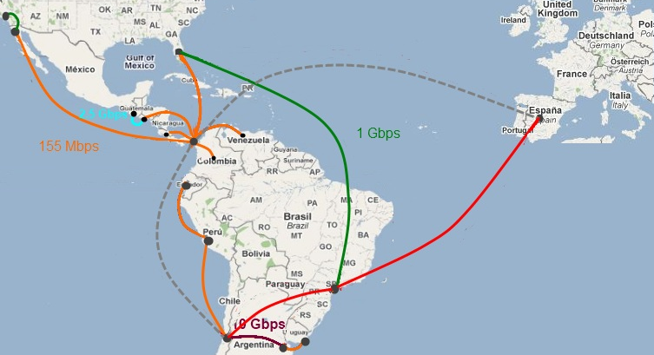

The technical manager’s presentation also showed the projected network. The network will be available by the end of the ALICE2 project. This network is shown in the following map, taking into account the recent awarded tender procedures.

The technical report continued with a description of the engineering activities. The NEG carried out a routing plan update for the RedCLARA’s new topology. The routing plan has as the main focus, the redundancy of the network. The plan is to use specific Ethernet paths that will act as a backup, when some routers could get damaged or go offline. The following figure illustrates the idea behind this plan:

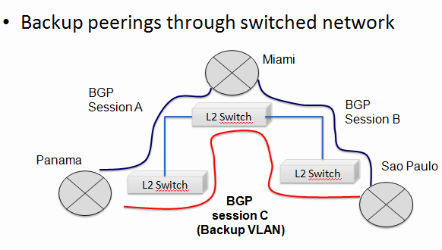

As it is shown in the figure, the NEG will work in activating a backup peering that jumps one of the core routes. The above will protect the traffic in case of a failure in the middle router.

The routing plan has also some rules and configurations used to guarantee the selection of the best path for international networks. The above in response to some BGP decisions issues encountered for some or the regional partners.

The presentation contained also, a report of the Network Operations Center (NOC). The report described the main operations indicators that highlighted some issues that affected the link between Buenos Aires and Santiago de Chile.

The technical manager’s presentation concluded with a description of the RedCLARA’s new portal. The portal is providing a unique point to access RedCLARA’s services. The portal includes services like:
a) Web-conference
b) VC reservation system (SIVIC)
c) Video repository
d) Financing fund's database
e) Collaboration suite to connect partners (find partners)

RedCLARA’s portal services (Presented by Carlos Gonzalez):

Carlos Gonzalez, the RedCLARA’s software projects leader engineer, carried out the next presentation about the RedCLARA’s services. Carlos’ presentation was focused toward showing the portal launched in March/2011. The following graph lists the current portal services:

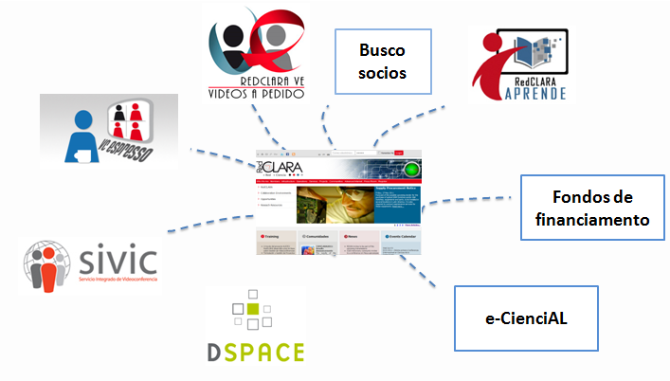

Carlos continued by explaining each service like:

- SIVIC: The Integrated Video-conference service with its reservation system. The portal will include this service as one of the main components.

- VCEspresso: A web-conference system oriented to the communities. VCEspresso allows multi-party video-conferences using just a browser. Furthermore, the participants can share content and chat in the conference room.

- RedCLARA VE: A video portal similar to Youtube, used to share video content. Each RedCLARA’s communities have the ability to upload academic content.

- Busco Socios: Is a partner search application. A researcher can search for people working in the same areas, or projects.

- RedCLARA Aprende: A distance learning tool based in the Moodle platform. The idea is that the communities can develop courses for their groups using this system.

- E-CienciaAL: A database system that can be accessed to search for financing funds, and programs. The users can also register to receive alerts of recent opportunities.

Carlos continued by providing a description of each service’s architecture, and some screenshots of how to use them.

Grid Initiatives for e-Science virtual communities in Europe and Latin America (GISELA) project update:

Gilberto Diaz, the GISELA WP5 Manager, presented the updates. Gilberto started by providing a summary of parallel computing and Grid basis. Gilberto mentioned that the “Grid is a form of distributed computing where different institutions decide to share their resources in order to extend the compute power”. The presentation showed that the GISELA project was co-funded by the European Union within the 7th programmee.

In the following graph, Gilberto described the current participants in GISELA project:

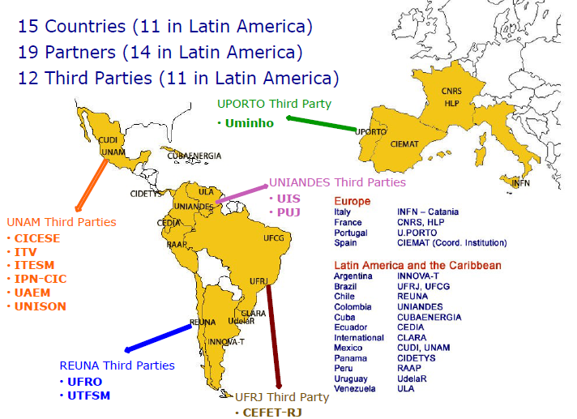

After describing some of the main GISELA statistics, Gilberto also mentioned the contributions of the GISELA project to RedCLARA that he summarized as:

- The Installation of measurement points in the resource centers and integrate them into the CLARA monitoring platform, permits the determination of the inner state of the NRENs.

- Offers a suitable platform for research communities of CLARA for massive storage and intensive computing.

6DEPLOY: IPv6 Deployment Support Project Overview:

Alvaro Vives from the provider Consulintel carried out the presentation of the IP6DEPLOY project. Alvaro began with an introduction where he described the project. The IPV6DEPLOY has part of his funding from the European Commission with 1 Million Euros. The project’s partners include 13 organizations that include commercial providers (Cisco, Consulintel), NRENs (RENATER, GRNET, FCCN, NIIFI, HUNGARNET, UNINETT, BREN), RIRs (AfriNIC, LACNIC), and Universities (UCL, Soton-ECS).

Alvaro explained that the IPV6DEPLOY will take the preceding experience from projects like 6IDSS. The IPV6DEPLOY project has goals like:

- Organize workshops for the IPv6 community
- Work on deployments in Europe and in development countries
- Improve European competitiveness
- Gain expertise in support more commercial deployments

The following figure shows the path of the work to be carried out along the project:

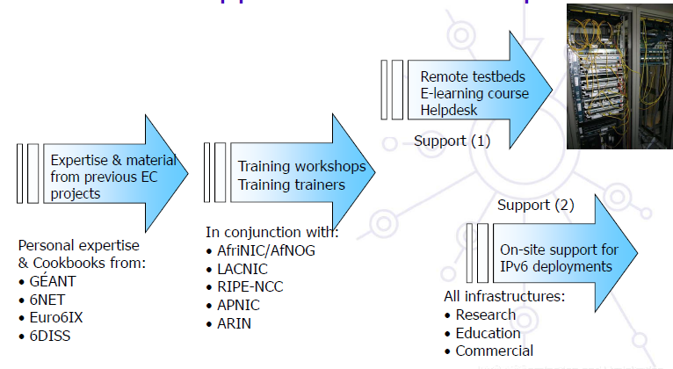

At the end, Alvaro presented a summary of the project results. The project carried out six workshops in countries like Brazil, Haiti, Nairobi, Maputo, Singapore, and Bali. Furthermore, he mentioned the nine world wide IPv6 labs in Bulgaria, France, Mauritius, Kenia, Kyrgyzstan, Georgia, India, Spain and Slovenia.

Latin-American and Caribbean Internet Addresses Registry (LACNIC), IPv6 related activities

Carlos Martinez, representing LACNIC, started its presentation describing LACNIC’s organization and functions. He mentioned that LACNIC administers the IPv4, IPv6, AS numbers for Latin-America and the Caribbean. LANIC provides services like whois a directory, reversal DNS, and RPKI.

Carlos presented the main statistics regarding the availability of IPv6 resources. In the following graphs are presented some of them:

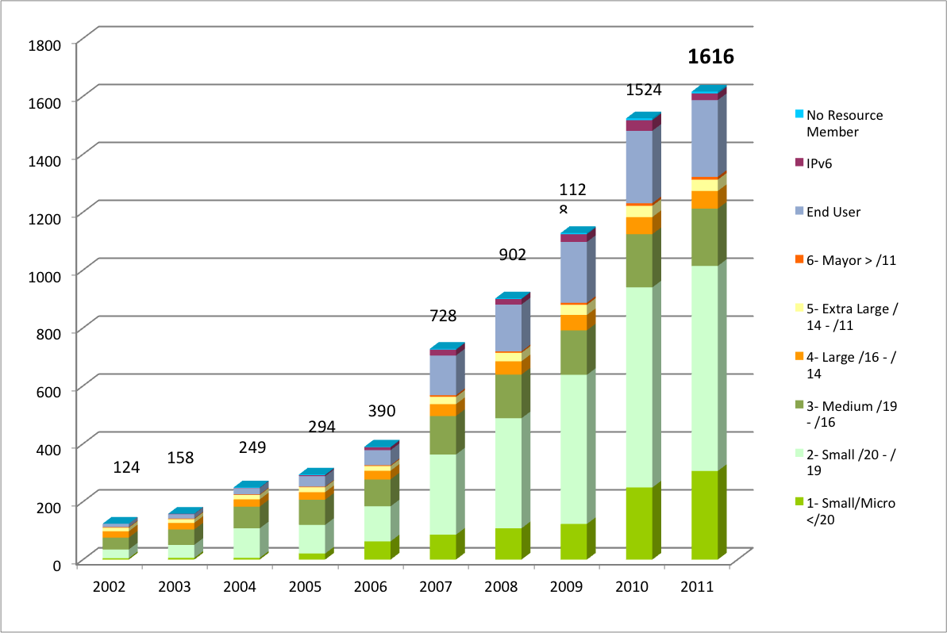

LACNIC’s membership evolution

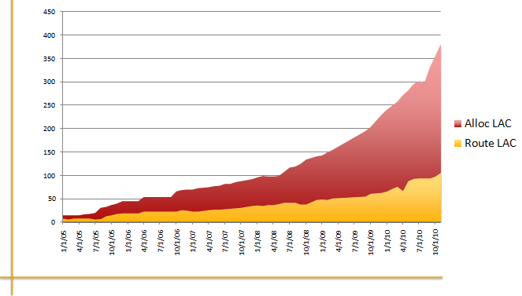

IPv6 assignments and routing

Carlos highlighted the speculation that could occur when the IPv4 resources become unavailable.

Openflow: What is the role in network research (Michael Stanton)

Michael Stanton, from RNP, did the presentation of the Openflow. Michael started describing the PlanetLab project. PlanetLab is the global distributed lab environment. The project is based on virtualization of computing resources along the globe, in order to provide virtual laboratories for education and research projects.

The PlanetLab project was used as an introduction to the Openflow network test environment concept. Openflow allows building an entire networking lab over the production infrastructure. The concept is very powerful, because the future Internet project assures that “The future Internet will be created as an overlay in the current one”.

In PlanetLab, there is the concept of Slices. A slice is a space where the researchers can create virtual machines for their tests. In Openflow, the concept of slices would be implemented in the network.

Michael mentioned the concept of Software Defined Networks (SDN) that is powered by projects like Openflow. Future Internet initiatives like GENI (Global Environment for Network Innovations) will be taking advantage of the Openflow concepts.

Openflow can be summarized as the separation of the network control and switching planes. The above would be implemented by centralization of forwarding rules outside basic switching equipments. The following graph describes the Openflow architecture.

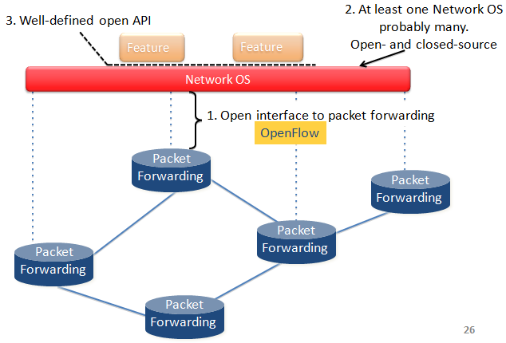

Openflow @ HP:

Alvaro Renata, from the provider HP, carried out a presentation about the company steps in Openflow. Alvaro showed how the company has developed switches with Openflow support, and they have been bought from various academic institutions working with the technology.

Alvaro mentioned some early adopter projects in:

- Perform large experimenting
- Leverage parts of the production network
- Optimized data operation
- Differentiated services for dynamic traffic redirection
- Network virtualization

RedCLARA working groups 2009-2010 evaluation:

Iara Machado, from RNP and the RedCLARA working groups’ leader, presented an evaluation of the working groups of the last period. The evaluated groups where:
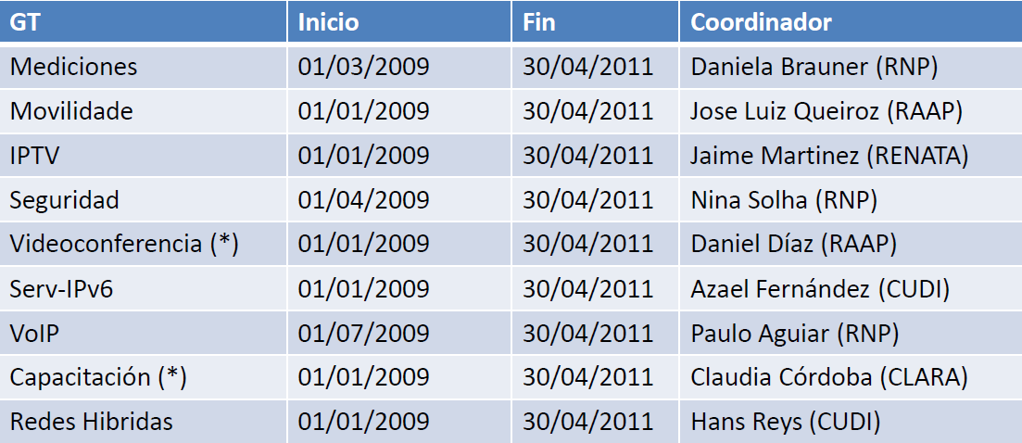

From the groups’ evaluation, Iara mentioned some learned points that could improve future work:

- Sometimes, the groups’ plans are very optimist, and it is preferable to have a less ambitious plan that can be completed and 100%.

- The groups’ coordinators shall have leadership, perhaps this variable can be evaluated in future calls.

Some suggestions to improve groups’ work:

- Establish some stimulus for the groups people
- Get some feedback from RedCLARA’s operational areas about tasks completed by the group
- Technical committee’s support to the group in diffusion and promotion of groups’ activities.
- Search more diffusion channels

Iara continue with information about the new groups call for 2011. The following is the list of the groups proposals received:

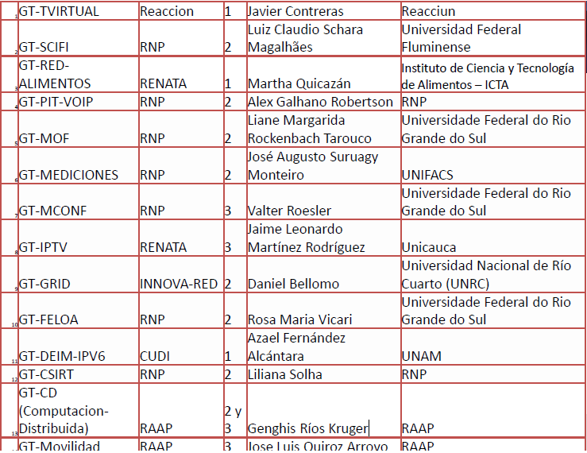

The evaluation commission decided to accept the proposals from nine groups: a) Measurements, b) CSIRT, c) Mconf, d) SCIFI, e) DEIM-IPv6, f) Mobility, g) IPTV, h) PIT-VOIP.

GT-CSIRT (Computer Security Incident Response Team for RedCLARA):

Claudia Inostroza carried out the presentation for the group. Liliana Velasquez Sonha will be the groups’ coordinator. Liliana has a lot of experience in the field because she leads the security groups in RNP also. The main focus of the group will be:

- Security threads monitoring
- Security incidents treatment
- CSIRT’s creation

Liliana presented the following chronogram that summarizes the main planned activities:

GT-MOF (Mobility):

This group will be led by Liane Tarouco, with the support from Leandro Bertholdo both from RNP. Leandro carried out the presentation. Leandro began with a description the orientation of mobility using Openflow. The main goals of the group are:

- Research and develop a WiFi mobility solution using Openflow.
- Reduce hand-off time achieved in current technology implementations.

The group listed as its main activities:

- Openflow technology study
- Implement labs, first using Mininet and following with switches using the NOX protocol.
- Define comparative methods and statistics for the results’ evaluation
- Implement the solution and take statistics and measurements.

FRIDAY JUN 24/2011

GT-DEIM-IPv6 proposal for RedCLARA:

The Friday sessions started with the IPv6 working group led by Azael Fernandez Alcantara from Autonomous University from Mexico (UNAM). Azael presented the group proposal that is based on the continuation of the work carried out in the previous version of the group. The groups name is the acronym for Deployment and Implementation of IPv6 (DEIM-IPv6). The above describes the orientation of the group that has the following goals:

- The promotion, planning and deployment of IPv6 across RedCLARA and its NRENs.

The tasks planned for the group are:

- IPv4 analysis for the NREN and RedCLARA
- Phase I: Planning and design of IPv6 addressing
- Phase II: Planning and design of IPv6 routing
- Phase III: Planning and design of IPv6 security models
- IPv6 deployment
- Web services IPv6 implementation
- DNS IPv6 services implementation
- E-mail IPv6 services implementation
- RedCLARA’s IPv6 day

GT Measurements:

Jose Augusto Suruagy from the NREN RNP, carried out the measurements group presentation. Jose’s presentation started by mentioning that the group will continue with the successful work developed between 2009 and 2010. The presentation described the Perfsonar application, based for the services implemented by the group.

The professor Suruagy explained the new tasks for the group including:

- Continue with RedCLARA measurements
- Promote the deployment inside the RedCLARA’s NRENs
- Collaborate in the deployment in RedCLARA’s trunk
- Periodic testing with partner networks to guarantee the performance

Other activities to be carried out by the group include the training, and Perfsonar versions upgrade.

GT Mobility

Jose Luis Quiroz, from the RAAP, presented the proposal for the mobility working group. The mobility group works with the EDUROAM technology. EDUROAM is a project that allows wireless roaming along academic institutions worldwide. Jose Luis listed the goals:

- Spread and deploy the EDUROM-LA service.
- Organize the EDUROAM-LA operations team
- Support and advise to the NRENs on EDUROAM’s implementation.
- Explore new authentication methods, support technologies and IP mobility techniques.
- Establish and strength RedCLARA’s relations with internal and external NRENs, by collaborating in projects and activities related to mobility.
- Collaborate and support in other groups’ activities.

Jose Luis presented a chronogram for the group’s activities. Furthermore, he mentioned the partners that are collaboration in the project.

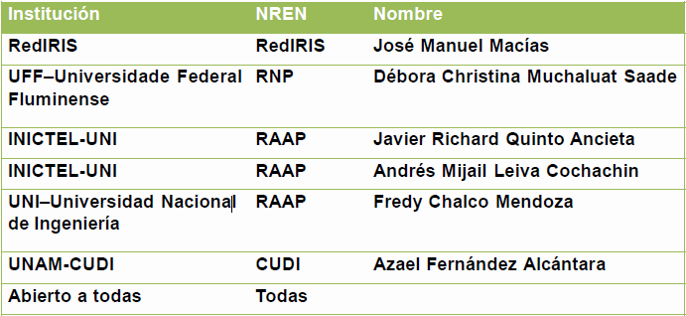

GT IPTV

The IPTV working group is lead by Jaime Martinez who carried out the presentation. Jaime showed the groups’ goal:

- Implement up to the production stage, an IPTV platform for the RedCLARA’s NRENs. The platform shall allow services like multi-channel IPTV and IPv6 Multicast support.

Jaime’s presentation also contained a detailed tasks description. The tasks included:

- Install a testing environment on the NRENs
- Integration of the module for programming where each NREN could add its content and define the presentation dates and times.
- Integration of the multi-channel module
- Multicast modulo integration
- IPv6 module integration
- Monitoring module integration

Jaime mentioned the institutions that are collaborating with the group:

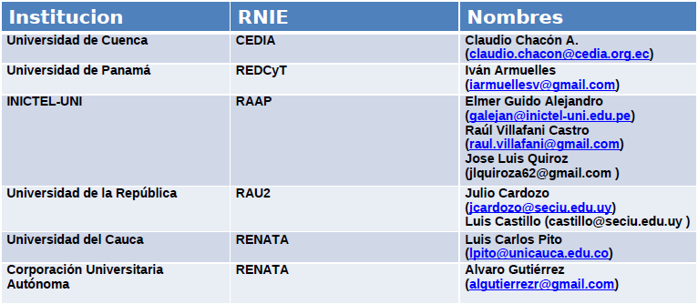

GT PIT VOIP (VOIP Traffic exchange point)

Alex Galeano from RNP, was the leader in the presentation of the VoIP group. The idea of the group is to implement a traffic inter-exchange point for VoIP in RedCLARA. Furthermore, the group will work on additional promotion activities to disseminate the services to the NRENs. The service model proposed by the group is in the following figure:

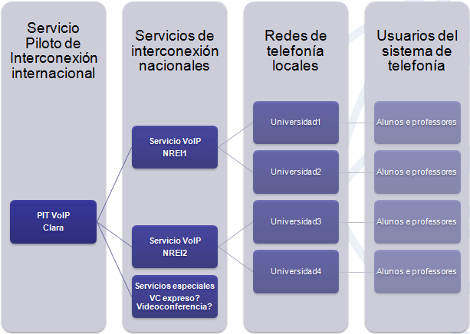

The group also presented the tasks lists and the schedule for the activities up to 2013. Some of the main activities mentioned were:

- Analysis of previous GT VOIP work
- Study of the NRENs VOIP actions
- Policies and participation rules for the PIT
- Define functional and technical characteristics of the system
- Develop and adapt the PIT system
- Training to the system operators
- Produce ‘Manual for PIT connection’
- Actions to disseminate the service
- Install the testing service
- Results study

GT SCIFI

The professor Luiz Claudio Schara Magalhães presented the SCIFI group. The group is focused on the study and deployment of an Intelligent Control System for Wireless Networks. Luiz explined the tendency of having more and more Access points on the institutions, and the requirement to have a centralized control of them. In general terms, with the increasing amount of Access points and elements, the administration complexity is increasing. The SCIFI working group aims to work in solutions for this dilema.

Implementations like channels configuration, Power control and load balancing will be available through this initiative. Luiz explained the technical details and motivations for each of those functionalities. The group’s work will take into account the EDUROAM network.

GT MCONF

The Multi-conference working group is to work in the deployment and enhancement of a Web-conference system. The presentation was carried out by Valter Roesler (UFRGS) from RNP. Valter and the group’s work will be in collaboration with the Big Blue Button (BBB) development team. The BBB is a very popular, open-source Web-conference implementation. Valter started by giving an overview of the BBB testing they have been done. The following figure shows the testing with 80 users, and he mentioned some audio problems with the hardware configuration they used:

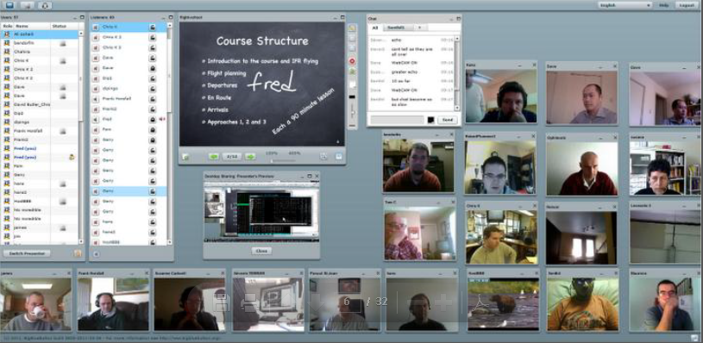

Valter also showed the integration with mobile devices. The group developed an Android application of the BBB, and a reservation system based on the Global Plaza code.

The main group activities mentioned by Valter were:

- General improvements in the BBB core and bugs fixing
- Installation of a server for RedCLARA
- Deployment of a web management system in Spanish
- Applications for mobile integration
- Multiple servers for load-balancing
- Improvements in audio and video quality

TICAL Report

Sandra Jaque, from REUNA, continued with a presentation report of the TICAL event carried out by RedCLARA. TICAL was an event for all the IT directors of the universities or institutions that are affiliated to the NRENs. The directors were joined to share, disseminate and generate ideas about possible projects, good practices, interests and the future of the information technologies in their institutions.

The conference had 90 participants from all Latin-America. In the conference, the participants formed discussions on themes like:

- IT Governance
- High performance computing
- Service Management
- Federated services (VoIP, Eduroam, federaciones)
- Knowledge management

GEANT Services and Regional Projects update

Tom Fryer, in representation of DANTE, carried out the presentation of the GEANT network. Tom started with a brief of the current GEANT services:

- EduPERT: A federated Performance Enhancement Response Team. The project includes local and regional PERT projects that aim to improve overall network performance.

- Perfsonar MDM: Multi-domain Diagnostics Services. Tom mentioned the first transatlantic operational use: RNP-RedCLARA-GÉANT-RedIRIS on Thursday, 16th June.

- EduROAM: Wireless access roaming services. Allows students, researchers and staff from participating institutions to obtain Internet connectivity across campus.

- EduGAIN: Federated Authentication and Authorization infrastructure.

- EduPKI: A trust factory used to provide certificates for GN3 services.

- EduCONF: To study the feasibility of a pan-European Video-conference service.

Tom explained each of the services, and explained how the development of them is oriented. Tom followed the presentation with the overview of the regional projects. The projects included the EUMEDCONNECT (North Africa and Mid-east), CAREN (Central Asia), TEIN3, and AfricaConnect. The EC provides funding for these projects. The funding is 4 million (50% of EUMEDCONNECT), 5 Million (80% of CAREN), 21.4 Million (TEIN3), and 15 Million (AfricaConnect).

Café (Identity Federation Service for Research and Education)

Antonio Carlos Nunez, from RNP, carried out the presentation about CAFÉ. Antonio began describing the service development methodology from RNP. Based on ITIL v3, the method involves phase like: a) prototype deployment, b) Pilot phase, and c) experimental phase.

Antonio explained that Café is a federated identity network service that joins Brazilian academic and research institutions in one trust network. The Café service was launched in the second semester 2010. Antonio described that Café is based on Shibboleth, a federated system developed by Internet2. The main concept of the service is to have Service providers (SP), and Identity Providers (IP). The users would enter to a single authentication system. The identity would be confirmed by the IP, and the service granted through the SP.

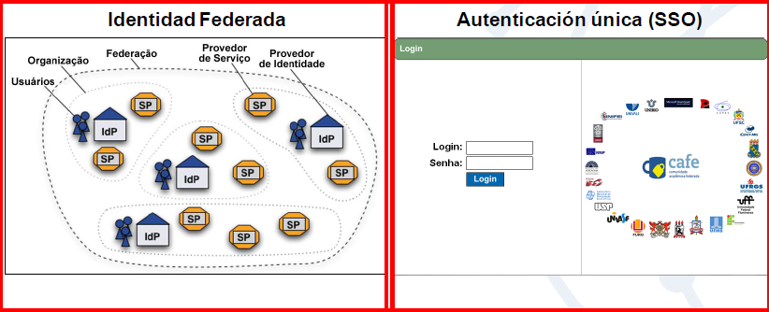

Antonio also showed a list of the current service and identity providers at RNP. The service providers include:

- Atlases: Visualization of patology images in high definition;
- Dreamspark: Programs and servers for systems development;
- Portal de Periódicos da Coordenação de Aperfeiçoamento de Pessoalde NívelSuperior (CAPES): Allows access to the virtual librarie without any proxies.

The Identity providers contained 12 institutions from Brazil.

