

 |  | 
A project of the @LISII Programme | This project is funded by the European Union | A project implemented by CLARA
European Union’s @LIS II Programme for Latin America

ALICE2 Project

Plan and design Fully Optical Paths


Periodical Progress Report
ALICE2 Deliverable: ALICE2 DO1.1-12-1.3

Document Full Name | ALICE2 DO1.1-12 Plan and design Fully Optical Paths v1.3
Date | 01-08-2011
Activity | To plan and design RedCLARA optical network
Lead Partner | RedCLARA
Document status | DRAFT
Classification Attribute | Internal to Project Partners
Document link

Abstract: This document’s main goal is to provide a reference of the optical projects carried by RedCLARA at the present year. The projects described include the path between Santiago-Lima and Buenos Aires-Sao Paulo.

Copyright notice
Copyright © Members of the ALICE2 Project, Aug 2011
ALICE2 (América Latina Interconectada con Europa 2 – Action Name: Extending and Strengthening RedCLARA as e-Infrastructure for Collaborative Research and Support to Development) is a project co-funded by the European Commission within the @LIS II Programme. ALICE2 began on 1st December 2008 and will run for 45 months.
For more information on ALICE2, its partners and contributors please see (after March 29th, 2009) http://alice2.redclara.net.
You are permitted to copy and distribute, for non-profit purposes, verbatim copies of this document containing this copyright notice. This includes the right to copy this document in whole or in part, but without modification, into other documents if you attach the following reference to the copied elements: “Copyright © Members of the ALICE2 Project, 2008. See http://alice2.redclara.net for details”.
Using this document in a way and/or for purposes not foreseen in the paragraph above, requires the prior written permission of the copyright holders.
The information contained in this document represents the views of the copyright holders as of the date such views were published.
THE INFORMATION CONTAINED IN THIS DOCUMENT IS PROVIDED BY THE COPYRIGHT HOLDERS “AS IT IS” AND ANY EXPRESSED OR IMPLIED WARRANTIES, INCLUDING, BUT NOT LIMITED TO, THE IMPLIED WARRANTIES OF MERCHANTABILITY AND FITNESS FOR A PARTICULAR PURPOSE ARE DISCLAIMED. IN NO EVENT SHALL THE MEMBERS OF THE ALICE2 COLLABORATION, INCLUDING THE COPYRIGHT HOLDERS, OR THE EUROPEAN COMMISSION BE LIABLE FOR ANY DIRECT, INDIRECT, INCIDENTAL, SPECIAL, EXEMPLARY, OR CONSEQUENTIAL DAMAGES (INCLUDING, BUT NOT LIMITED TO, PROCUREMENT OF SUBSTITUTE GOODS OR SERVICES; LOSS OF USE, DATA, OR PROFITS; OR BUSINESS INTERRUPTION) HOWEVER CAUSED AND ON ANY THEORY OF LIABILITY, WHETHER IN CONTRACT, STRICT LIABILITY, OR TORT (INCLUDING NEGLIGENCE OR OTHERWISE) ARISING IN ANY WAY OUT OF THE USE OF THE INFORMATION CONTAINED IN THIS DOCUMENT, EVEN IF ADVISED OF THE POSSIBILITY OF SUCH DAMAGE.

DELIVERABLE ROUTE
 |  | Name |  | Member/Activity |  |  | Date | Responsible
From |  | Marco Teixeira |  | RedCLARA NEG |  |  | 2011-08-06 | Gustavo García
Revised by |  | Gustavo Garcia |  | Technical Manager |  |  | 2011-08-10 | Gustavo García
Approved by |  | Florencio Utreras |  | CLARA/CEO |  |  | 2011-08-15 | Florencio Utreras
DOCUMENT DESCRIPTION
Subject | Date |  | Comment |  |  | Author
REGISTER OF CHANGES
Subject | Item |  |  |  | Reason for Change
TABLE OF CONTENTS
Content
Copyright notice 2
1. INTRODUCTION 5
2. Optical Projects 6
2.1. Central America 6
2.1.1. Providers 6
2.1.1.1. UFINET 6
2.1.2. Optical Paths 6
2.1.3. Equipments 8
2.1.4. Logical Design 9
2.2. Santiago Chile - Lima Peru 10
2.2.1. Providers 10
2.2.1.1. Telefonica 10
2.2.1.2. Reuna 10
2.2.1.3. Ciena 11
2.2.2. Optical Paths 11
2.2.3. Equipments 12
2.2.3.1. Path 1 Lima – Arica 12
2.2.3.2. Path 2 Arica – Antofagasta 12
2.2.3.3. Path 3 Antofagasta – Santiago 13
2.2.4. Logical Design 14
2.3. Buenos Aires – São Paulo 14
2.3.1. Providers 15
2.3.1.1. Global Crossing 15
2.3.1.2. RNP 15
2.3.1.3. PADTEC 15
2.3.2. Optical Paths 16
2.3.3. Equipments 17
2.3.3.1. Path 1 Buenos Aires – Porto Alegre 17
2.3.3.2. Path 2 Porto Alegre – São Paulo 19
2.3.4. Logical Design 21
2.4. Santiago Ring 21
2.4.1. Starting Infrastructure 22
2.4.2. Ending Infrastructure 23
3. REFERENCES 24

INTRODUCTION

One of the main CLARA’s goals consisted is achieving the network capacities for the second version of RedCLARA2. As part of this work, CLARA has been researching the telecommunication providers in the region that could fulfill its needs. The CLARA’s network needs are defined by two main goals, sustainability and the next generation network development. Sustainability defines the contract type; due to CLARA can achieve savings in annual costs with an investment, instead of renting, strategy. The next generation network development is crucial for promoting and enabling advance Latin-American academic and research activities. Activities like transferring large amounts of research data, GRID computing, high definition videoconferencing for medical applications, virtual presence and others require of a network with low latency, no errors and bandwidth always available. With these guidelines in mind, CLARA has focused its interests in fiber networks with capacities between 155 Mbps and 10 Gbps. CLARA looks for Irrevocable Right of Use (IRU) contracts that imply an investment but low recurrent charges. For the IRUs, the providers should offer OTU-1 (2.5 Gbps) or OTU-2 (10 Gbps) capacities or Dark Fiber. If these types of contract or capacities are not available, CLARA will look for fiber capacities between 155 Mbps and 2.5 Gbps for rental periods of 1 to more years. The biggest project carrier by RedCLARA will be the implementation of the new fiber access equipments for Central America, this solution will bring a huge improvement in performance and less future cost.

Optical Projects

Central America

Motivated by the ideal of reducing costs RedCLARA recently acquired from UFINET in the form of an IRU to contract a dark fiber that goes from Tapachula (MX) to Panama City (PA). With this project the demand for connectivity from the following countries can be met: Mexico, Guatemala, ElSavador, Honduras, Nicaragua, Costa Rica and Panama.
The initial project was to light this fiber with a DWDM equipment to bring high transfer rates and system scalability, due to the high cost (mainly linked to the long distance path) this idea had to be discarded and a single channel design considered. During the studies it was determined that the links must operate with at least 1Gbps Ethernet.

Providers

UFINET

UFINET is the Telecommunications Company of the conglomerate GAS NATURAL FENOSA.UFINET has its main presence in Spain, Central America, Panama, Colombia and Miami (NAP).

Optical Paths

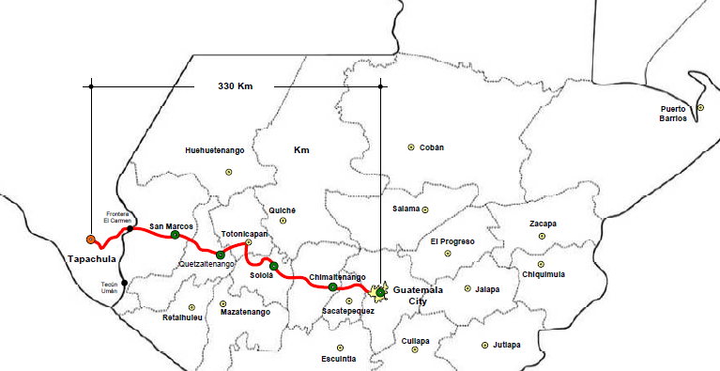

Figure no. 1. Fiber path 1, Tapachula - Guatemala

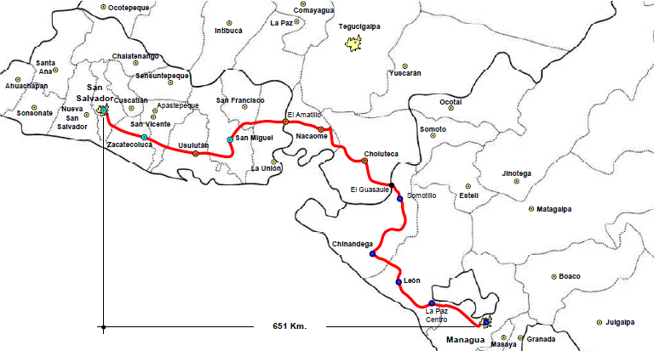

Figure no. 2. Fiber path 2, San Salvador - Managua

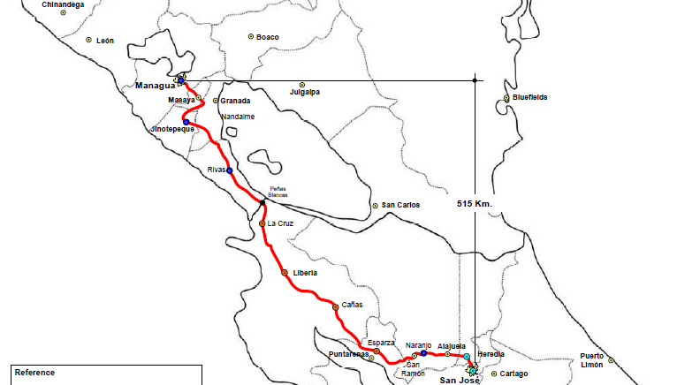

Figure no. 3. Fiber path 3, Managua – San José

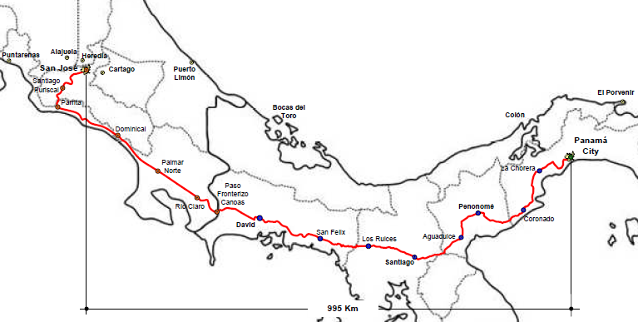

Figure no. 4. Fiber path 4, San José - Panamá

Equipments

As the bidding process has not yet been finalized, there is any specific equipment defined. Nevertheless, in this section we will describe the main guidelines of the specification for the equipments in Central America:

- Capacity

The equipments were required with a capacity of 1 Gbps Ethernet and the ability to grow at least to 2 Gbps Ethernet. Even if this is not a high capacity, compared to the 10 Gbps obtained for the Southern connections, it will fulfill the Central America’s demand for a good period, and will fit into RedCLARA’s budget. The main advantage is that RedCLARA obtained a dark fiber, what will permit the future upgrade of this infrastructure when the demand

- Type of equipment (CWDM, DWDM, GigaEthernet transport)

The state of the art in optical technology is the Dense Wavelength Division Multiplexing (DWDM). But, this technology is also the most expensive at the time. DWDM technologies are designed to have multiple 10 Gbps (or more) channels over a single fiber. The Coarse Wavelength Division Multiplexing (CWDM) is another technology used to transport multiple, high capacity, links over a single fiber, with a cheaper elements and more limited capacity and reach. Other fiber technologies exists to transport a single 1 or 10 Gbps Ethernet link over fiber, the main advantage is the cost, and the disadvantage is the capacity to grow. Due to the limited capacity used in Central America, RedCLARA decided to buy the best value / technology option it can obtain from the tender procedure, not defining the specific technology to be used. In the tender procedure to be done in August /2011, RedCLARA will ask for a solution that can fulfill the following criteria:

- Can provide the 1 Gbps Ethernet, and grow to at least 2 Gbps Ethernet.

- The solution includes a remote monitoring system.

- The overall cost of the solution is low.

Certainly, RedCLARA will take the grow capacity, and technology as two main components in the tender evaluation.

Logical Design
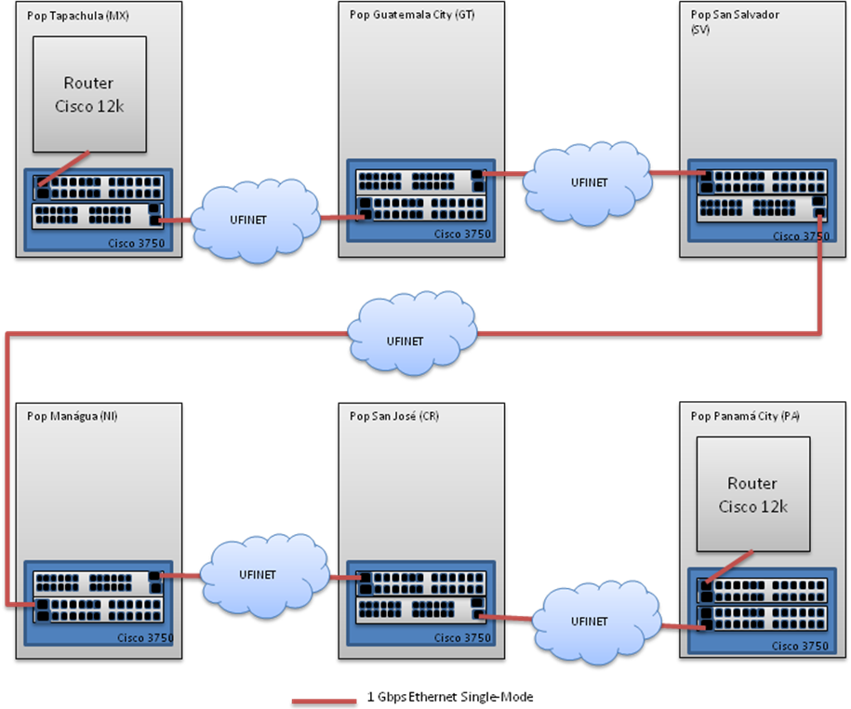
Figure no. 5. Logical design path Tapachula – Panamá City

Santiago Chile - Lima Peru

Motivated by the ideal of reducing costs RedCLARA recently acquired from Telefônica two paths in the form of an IRU contract: The first path is an OTU1 circuit that goes from Lima (PE) to Arica (CL) and the second path is an OTU2 that goes from Arica (CL) to Antofagasta (CL).In agreement with Chilean Network, RedCLARA will have the last mile that goes from Antofagasta (CL) to Santiago (CL) provided by REUNA. With this grow will be possible to transfer data 10% faster than the actual link. This project will meet the demand for connectivity from the following countries: Peru and Ecuador.

Providers

Telefonica

Telefônica International Wholesale Services (TIWS) is the organization within the Telefônica Group that provides global telecommunication services for fixed and mobile carriers, ISPs and content providers. Its portfolio includes international voice, IP, capacity, satellite, mobility, platform and international services for corporations.
Telefônica International Wholesale Services uses state of the art technology in all its services and products. It has a TIER 1 Backbone offering direct connectivity between Latin America, USA and Europe through a large international fiber optic network including, among others, the submarine cable, Sam-1. The company carries over 20 billion minutes of international voice a year through its NGN network and its more than 300 direct routes with international carriers.
TIWS also provides IT global and convergent solutions to multinational companies out of the Telefônica Group's footprint thanks to its large IP/MPLS network with POPs in more than 40 countries and local agreements with local and mobile carriers and integrators.
Telefônica International Wholesale Services is a leader global solutions provider in the international wholesale market, with a wide and competitive portfolio of services and outsourcing solutions for international carriers, with presence in the main European and American markets.

Reuna

With a mission to connect and strengthen collaboration among all universities, libraries and research centers in Chile, and the dream of making a future look alike foreign institutions of similar vocation emerged in 1986 REUNA as cooperative organization of university interconnection; in 1990 the National Commission for Scientific and Technological Research, CONICYT, gives his support to the entity in 1991, is constituted as a corporation of private non-profit.

Ciena
Ciena offers network infrastructure solutions, intelligent software and a comprehensive services practice. Their portfolio of software-centric optical and Ethernet platforms combines network element programmability, operating system commonality, management unification and Carrier Ethernet-based transformation to enable customers to change the way they compete. The solutions form the foundation of many of the largest, most reliable and sophisticated service provider, enterprise, government, and research and education networks across the globe.
During the EVALSO project implementation, lots of equipments were acquired from Ciena, and as a result from that, now the European Research has a competitive edge having faster access to the collected data and uses the facilities in an ever more efficient way.

Optical Paths

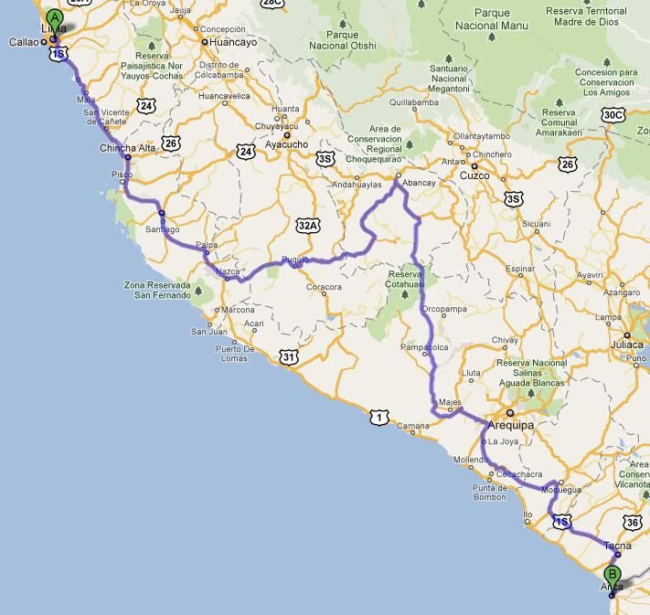
Figure no. 6. Fiber path 1, Lima - Arica
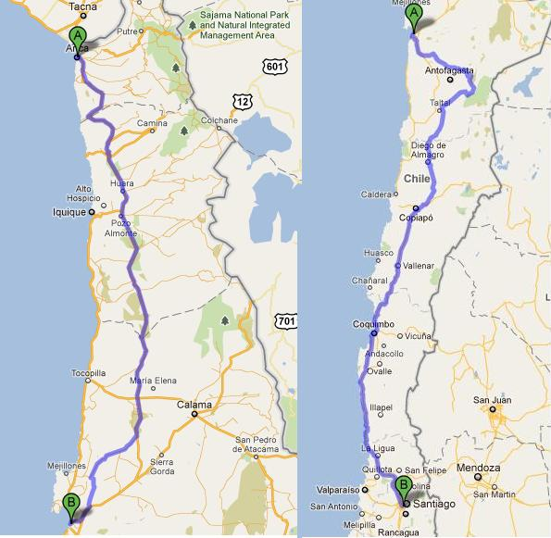

Figure no. 7. Fiber path 2 e 3, Arica – Antofagasta / Antofagasta –Santiago

Equipments

Path 1 Lima – Arica
For this path Telefonica will provide and IRU with the capacity of +/- 2.5 Gbps, this link will be provided with two Gigabit Ethernet Interfaces. As this path just establishes bandwidth capacity no equipments needed to be purchased.

Path 2 Arica – Antofagasta
For this path Telefonica will provide a dark fiber with OTU2 capacity. With the agreement made between RedCLARA and Reuna, it was possible to optimize the structure as Reuna already had some equipment in Antofagasta. With this in mind RedCLARA manage to acquire new interface cards for the Ciena chassis present in Antofagasta and a new module to be placed in Arica. This proposal was won by Adexus and is described as follows:
The solution provides 2 services of 1 GEthernet and one service OTU1, as show in the diagram below:
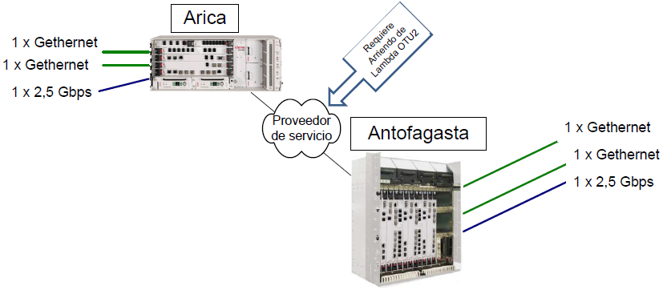
Figure no. 8. Adexus proposal description

All the equipments are from Ciena 4200 Family, more information’s can be found at: http://www.ciena.com/products/4200/

Path 3 Antofagasta – Santiago
For this path RedCLARA got the support from Reuna and will use an existing system to transport 2 services of 1 GEthernet. With this aid RedCLARA will be able to transport data 12% faster than the existing link. The equipments used by Reuna are a Ciena 4200 RS in Antofagasta and a Ciena 4200 Classic in Santiago. As the equipment in Antofagasta is the same that receives the link from Arica a jumper (inside Ciena box) will be made and the data can flow direct to Santiago. At Santiago Reuna will provide two interfaces GEthernet to be connected to RedCLARA Switches.

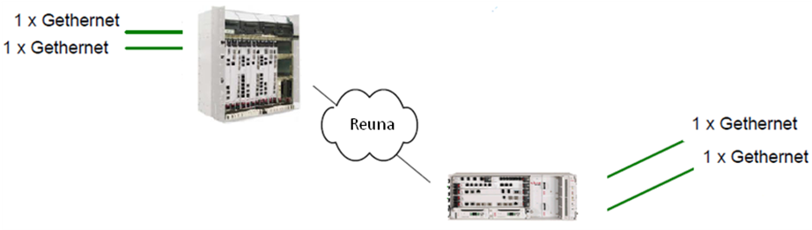
Figure no. 9. Reuna network description

Logical Design

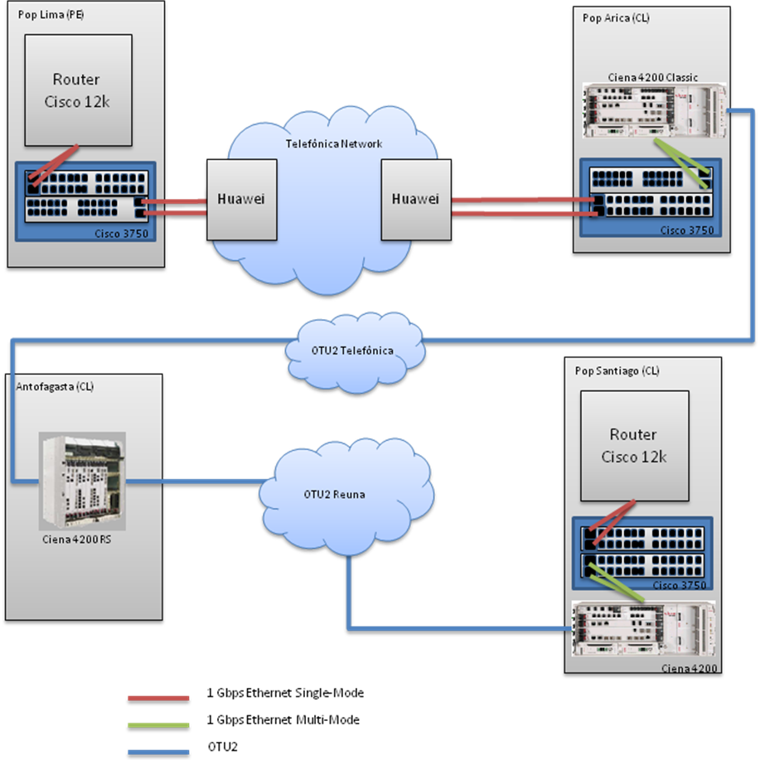
Figure no. 10.Logical design path Lima – Santiago

Buenos Aires – São Paulo

Motivated by the ideal of reducing costs RedCLARA recently joined efforts with RNP and Global Crossing to provide an infrastructure from Buenos Aires to Porto Alegre. This agreement was made to build a new optical network and benefit the three institutions. Global Crossing will enter with the fiber coasts and RNP/RedCLARA will finance the equipments (PADTEC) coasts. The system will be able to transport up to 40 channels of 10 Gbps. At the beginning only 6 channels will be installed (two for RNP/RedCLARA and four for Global Crossing). As the point of presence of RedCLARA in Brazil is based at São Paulo, RNP will provide a l2 VPN between Porto Alegre and São Paulo inside its own backbone; with this will be possible to transport data from Buenos Aires to São Paulo.

Providers

Global Crossing
Global Crossing is one of the main carries that delivers converged IP services to more than 70 countries and 700 cities around the world. The provider owns the Mid-Atlantic Crossing (MAC(R)), South American Crossing (SAC(R)) and Pan American Crossing (PAC(R)) undersea fiber-optic cable systems. The MAC connects the PAC, SAC and Atlantic Crossing-1 (AC-1(R)) subsea systems to provide full connectivity between North America, Latin America and Europe. The PAC submarine fiber cable network goes through the Pacific lading in Grover Beach, Calif., Tijuana, Mexico, Mazatlan, Mexico, Esterillos, Costa Rica, and Fort Amador, Panama.

RNP
The first network for Access to the Internet in Brazil, the National Education and Research Network (RNP) is made up of close to 600 educational and research institutions in the country, benefitting more than one million users. In 2005, the Science and Technology Ministry (MCT) launched the Nova RNP (New RNP). The objective was to improve network infrastructure at the national, metropolitan and local levels (campus networks); using applications and innovative services, serve the needs of specific communities (telemedicine, biodiversity, astronomy, etc.); and promote the qualification of human resources in information and communication technologies.

PADTEC
Padtec is a company dedicated to the development, manufacturing and sales of optic communication systems. The company provides solutions for long distance networks, as well as metropolitan and access networks. Padtec is the first and largest Latin America´s manufacturer of WDM transmission systems – transmission technology able to multiply increase the transmission capacity of optical fibers.
As a young company, Padtec has already conquered a solid reputation in the telecom market. With products focused on customers’ core business, Padtec offers highly competitive networks solutions, wide ranging of technical support and agility in attending customers within a short delivery time.
Less than a year after its foundation, Padtec has incorporated in its line of products, signal transport equipment according to OTN (Optical Transport Network) recommendations, reconfigurable optical add drop multiplexers (ROADM), multiprotocol traffic aggregator equipment, and an optical amplification solution for ultra long distance. Padtec has consolidated itself as a global provider of high technology customized solutions with businesses and representatives in South America, Central America, Europe and Asia.

Optical Paths

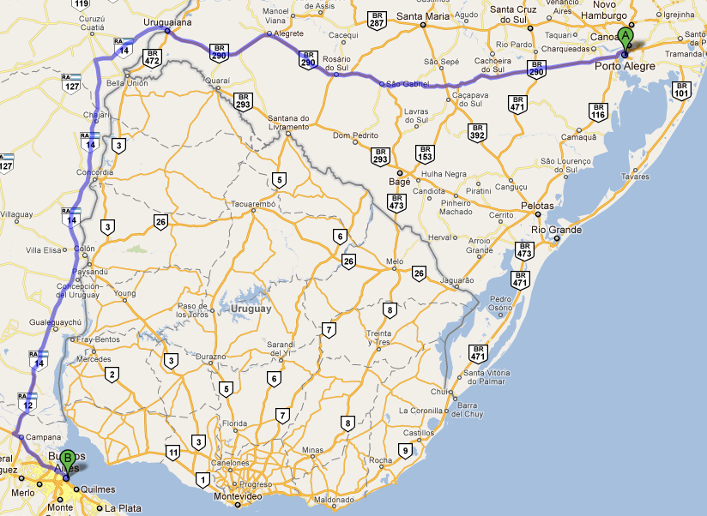
Figure no. 11. Fiber path 1, Buenos Aires – Porto Alegre
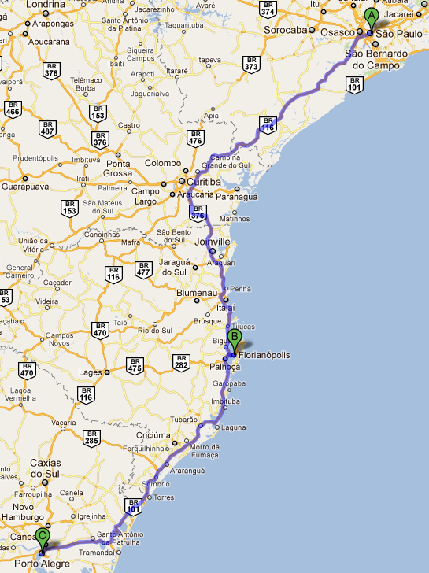

Figure no. 12. Fiber path 2, Porto Alegre – São Paulo

Equipments

Path 1 Buenos Aires – Porto Alegre
For this path the group will be able to use up to 40 channels of 10 Gbps. At the beginning only 6 channels will be installed (two for RNP/RedCLARA and four for Global Crossing) and the total throughput of the system can reach up to 400 Gbps.
RedClara will start using just 1 Gbps and when needed will improve the bandwidth, this DWDM system will be operated by Global Crossing. All the equipments for this path will be provided by PADTEC with its LightPad 1600 platform and a summary of its operation can be seen below:

• In DWDM configuration, capacity of up to 160 channels at 10 Gb/s
• Optional tunable lasers (full band)
• In CWDM configuration, supports up to 16 optical channels at 2.5Gb/s
• Erbium Doped Fiber Amplifiers in booster, pre, line and remote pump configurations for DWDM (ultra long distance application) systems
• Raman amplifiers for long distance DWDM systems
• Optical channel protection OSNC (Optical Sub Network Connection), with additional transponder protection
• Capability of insertion/extraction (OADM) of any channel or set of channels configured in dual homing, assuring additional protection to inserted/extracted wavelengths
• Reconfigurable insertion/extraction (ROADM – Reconfigurable Optical Add and Drop Multiplex) with capacity of 40 channels with remote configuration of extracted channels
• Incorporates the new Optical Transport Network layer (OTN, G.709) supporting the ever increasing demand for bandwidth (Tb/s per fiber in DWDM links) and broadband services of 2.5 Gb/s and 10 Gb/s in SDH, Ethernet, ATM and IP technologies
• Has a combiner module with up to 8 inputs Multiprotocol (ESCON, GbE, Fiber Channel 1G, Fiber Channel 2G, FICON 1G, FICON 2G or Fiber Channel 4G) generating an output signal of 10 Gb/s OTN
• Has a Muxponder module that allows the multiplexing of 4 signals STM-16 (2.5Gb/s) into a 10 Gb/s OTN

This path will have more than 1800 Km so there will be several amplification nodes in the way, for that a huge optical project had to be prepared taking in account the fiber path described from Global Crossing. The picture bellow describes all the nodes that were taken in account for the optical project.

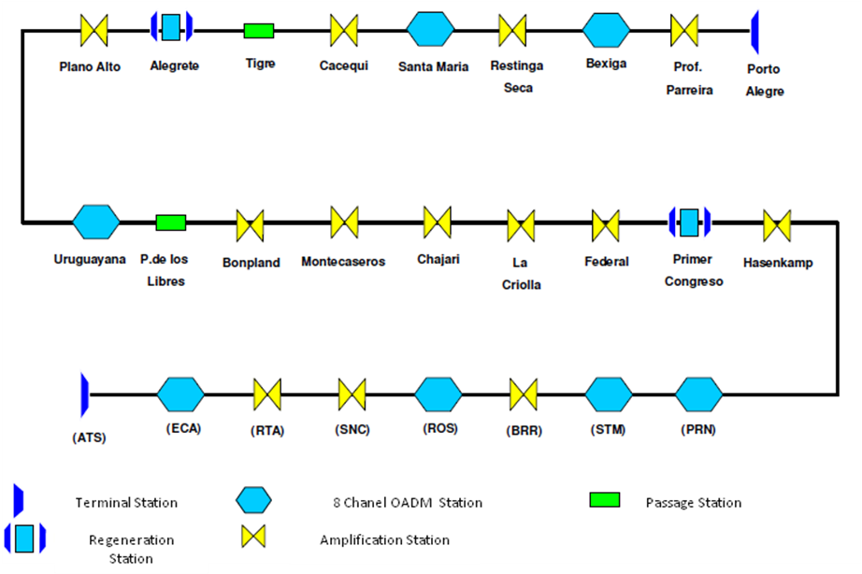
Figure no. 13. Fiber path nodes

Path 2 Porto Alegre – São Paulo
For this path RNP will provide RedCLARA a L2VPN with 1 Gbps. This technology works with their Juniper platform and will be the last mile to complete the Buenos Aires – São Paulo circuit.
This L2VPNs employ layer 2 services over MPLS to build a topology of point-to-point connections that connect end customer sites in a VPN. L2VPNs provide an alternative to private networks that have been provisioned by means of dedicated leased lines or by means of layer 2 virtual circuits that employ ATM or Frame Relay. The service provisioned with L2VPNs is also known as Virtual Private Wire Service (VPWS).
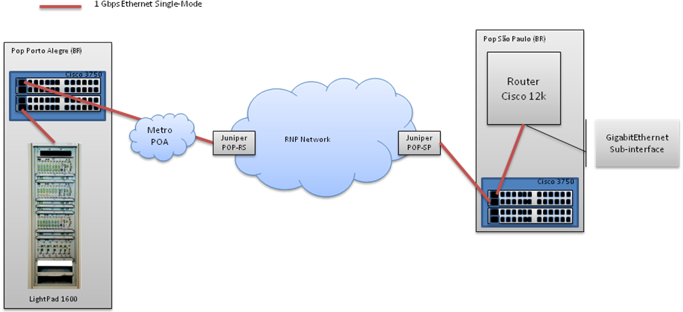
Figure no. 14. Last mile connections design

To reach Global Crossing pop at Porto Alegre RNP will have to build a new infrastructure, this link will be provide by the Metro POA and an exclusive Vlan will be addressed to isolate all traffic coming from RedCLARA to other networks.As RNP already have a connection with Metro POA just some logical configurations will be needed to build this path.
After reaching RNP pop, the Vlan will be extended thought all the RNP backbone with the support of their Juniper VPWS. RNP will give RedCLARA a new interface at its backbone in São Paulo with the Vlan addressed, with this link will be possible to reach Global Crossing pop and the system there established.

Logical Design

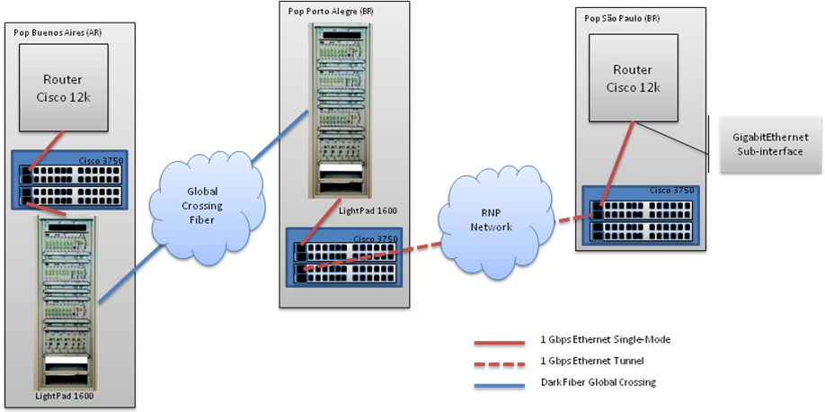
Figure no. 15. Logical design path Buenos Aires – São Paulo

As RedClara pop is already inside Global Crossing facility it will not be necessary to build a network to connect Clara equipments to the LightPad 1600. This cross connect will be made with the range of few racks.

Santiago Ring

Motivated by the ideal of offering a better service RedCLARA recently joined efforts with REUNA to provide a redundancy link between the two POPS at Santiago. This idea was planned after some failures in the main link that caused service unavailability. The main objective is to create a redundancy link through REUNA network so RedCLARA can transport its data even if the main link crashes.

Starting Infrastructure

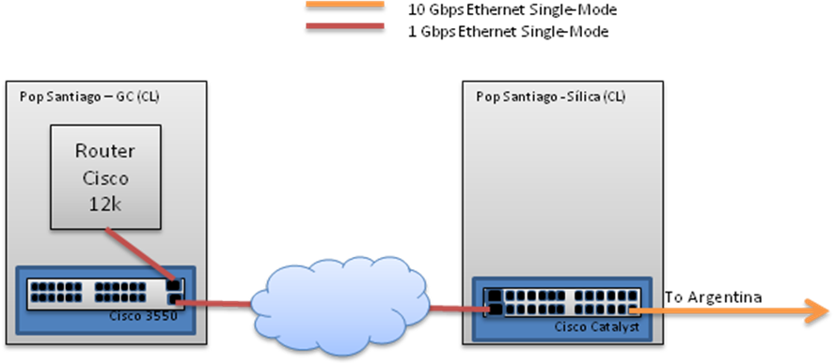
Figure no. 16. Logical design Santiago pops interconexión.

At this scenario, any problem caused to the link that connects the two pops would leave Argentina POP without connection. With the help of REUNA that already owns some equipments (Ciena) at Santiago, a new topology was planned to bring full redundancy for both networks. This cooperation will bring a huge improve of both services.

Ending Infrastructure

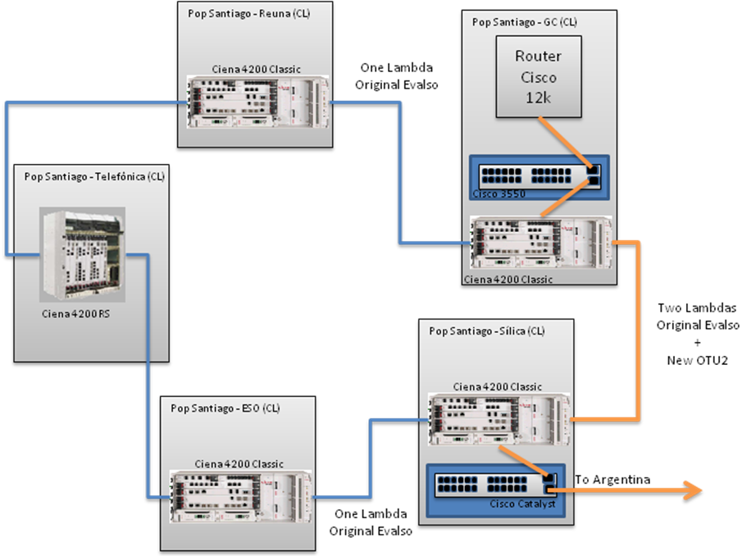
Figure no. 17. Logical design Santiago pop redundancy.

At this scenario, RedCLARA will buy a new Ciena 4200 Classic and will place it at Silica POP. This equipment will have the capacity to transport the original lambda and a new OTU2 service that will be used for RedCLARA main traffic. This will be achieved by the use of a 4 port multiplexer interface and a 10GbE. In case of a failure occurs between Silica and Global Crossing the traffic will be redirected to the other direction keeping the services available.

REFERENCES

- http://www.padtec.com.br
- http://www.ciena.com/
- http://www.rnp.br/
- http://www.reuna.cl/
- http://www.telefonica-wholesale.com/
- http://www.globalcrossing.com
- http://www.juniper.net

