

 |  | 
A project of the @LISII Programme | This project is funded by the European Union | A project implemented by CLARA
European Union’s @LIS II Programme for Latin America

ALICE2 Project
Deployment and Links’ Activation Plan


Periodical Progress Report

ALICE2 Deliverable: DO1.1-07-1.0

Document Full Name | ALICE2-DO1.1-07-v1.0 Deployment and Links’ Activation Plan
Date | 29-09-2009
Activity | To plan and design and optical RedCLARA network
Lead Partner | CLARA
Document status | DRAFT
Classification Attribute | Internal to Project Partners
Document link

Abstract: This document details the activities to be carried on for the installation of the links hired in the tender process of December 2009.

Copyright notice
Copyright © Members of the ALICE2 Project, May 2009
ALICE2 (América Latina Interconectada con Europa 2 – Action Name: Extending and Strengthening RedCLARA as e-Infrastructure for Collaborative Research and Support to Development) is a project co-funded by the European Commission within the @LIS II Programme. ALICE2 began on 1st December 2008 and will run for 45 months.
For more information on ALICE2, its partners and contributors please see (after March 29th, 2009) http://alice2.redclara.net.
You are permitted to copy and distribute, for non-profit purposes, verbatim copies of this document containing this copyright notice. This includes the right to copy this document in whole or in part, but without modification, into other documents if you attach the following reference to the copied elements: “Copyright © Members of the ALICE2 Project, 2008. See http://alice2.redclara.net for details”.
Using this document in a way and/or for purposes not foreseen in the paragraph above, requires the prior written permission of the copyright holders.
The information contained in this document represents the views of the copyright holders as of the date such views were published.
THE INFORMATION CONTAINED IN THIS DOCUMENT IS PROVIDED BY THE COPYRIGHT HOLDERS “AS IT IS” AND ANY EXPRESSED OR IMPLIED WARRANTIES, INCLUDING, BUT NOT LIMITED TO, THE IMPLIED WARRANTIES OF MERCHANTABILITY AND FITNESS FOR A PARTICULAR PURPOSE ARE DISCLAIMED. IN NO EVENT SHALL THE MEMBERS OF THE ALICE2 COLLABORATION, INCLUDING THE COPYRIGHT HOLDERS, OR THE EUROPEAN COMMISSION BE LIABLE FOR ANY DIRECT, INDIRECT, INCIDENTAL, SPECIAL, EXEMPLARY, OR CONSEQUENTIAL DAMAGES (INCLUDING, BUT NOT LIMITED TO, PROCUREMENT OF SUBSTITUTE GOODS OR SERVICES; LOSS OF USE, DATA, OR PROFITS; OR BUSINESS INTERRUPTION) HOWEVER CAUSED AND ON ANY THEORY OF LIABILITY, WHETHER IN CONTRACT, STRICT LIABILITY, OR TORT (INCLUDING NEGLIGENCE OR OTHERWISE) ARISING IN ANY WAY OUT OF THE USE OF THE INFORMATION CONTAINED IN THIS DOCUMENT, EVEN IF ADVISED OF THE POSSIBILITY OF SUCH DAMAGE.

DELIVERABLE ROUTE
 |  | Name |  | Member/Activity |  |  | Date | Responsible
From |  | Gustavo Garcia |  | CLARA /Technical Manager |  |  | 12/01/2010 | Gustavo Garcia, NEG
Revised by |  | Florencio Utreras |  | CLARA/Executive Director |  |  | 20/01/2010 | Florencio I. Utreras
Updated by |  | Gustavo Garcia |  | CLARA /Technical Manager |  |  | 01/03/2010 | Gustavo Garcia
Revised by
Revised by
Approved by
DOCUMENT DESCRIPTION
Subject | Date |  | Comment |  |  | Author
0-0 | 12/01/2010 |  | Deployment and Links’ Installation Report |  |  | Gustavo Garcia
REGISTER OF CHANGES
Subject | Item |  |  |  | Reason for Change

TABLE OF CONTENTS
Content
Copyright notice 2
1. INTRODUCTION 5
2. DEPLOYMENT PLAN 5
3. BASIC INFORMACION 6
3.1. Guatemala – El Salvador’s link information 6
3.2. El Salvador – Panama’s link information 7
3.3. Guayaquil – Lima’s link information 7
4. SPECIFIC TASKS 7
4.1. Guatemala – El Salvador installation 7
4.2. El Salvador – Panama installation 9
4.3. Guayaquil - Lima installation 11
5. REQUIRED EQUIPMENTS SUMMARY 12

INTRODUCTION

In the development of the ALICE2 project, CLARA is working in the consecution of links and capacities for the network in Latin-America. The CLARA’s focus is in obtaining Irrestrictible Right of Use (IRU) capacities that will cut down recurrent costs of the network. CLARA took another step in the fulfillment of this goal by carrying out a tender process for links in December 2009. As product of this process, three new links for CLARA where defined: Guatemala to El Salvador (OUT-1), El Salvador to Panama (STM-1) and Guayaquil to Lima (STM-1). It is worth mentioning that the link between Guatemala and El Salvador is the first IRU achieved by CLARA in the Central-America zone. Another important thing is that the link between Guayaquil and Lima will replace the last DS3 link in the network, and makes all CLARA links at least of STM-1 (155 Mbps) capacity. This deployment plan contains the steps and resources required to implement this new links in CLARA’s network.

DEPLOYMENT PLAN

The CLARA’s technical team needs to implement these new links that will improve CLARA’s network by replacing other smaller connections. It is worth mentioning the achievement of the first optical Central-America wavelength link of 2.5 Gigabits/sec between Guatemala and El Salvador. This deployment plan contains the details of the tasks and responsibilities in order to complete the activations on the required dates. The links to be installed product of this tender are:

Link | Capacity | Provider | Required installation date
Guatemala – El Salvador | OTU1 DWDM | Navega | 2010-03-20
El Salvador – Panama | STM-1 | Columbus | 2010-03-20
Guayaquil – Lima | STM-1 | Internexa | 2010-03-15

As result of the last tender process, the new CLARA’s network topology will be:

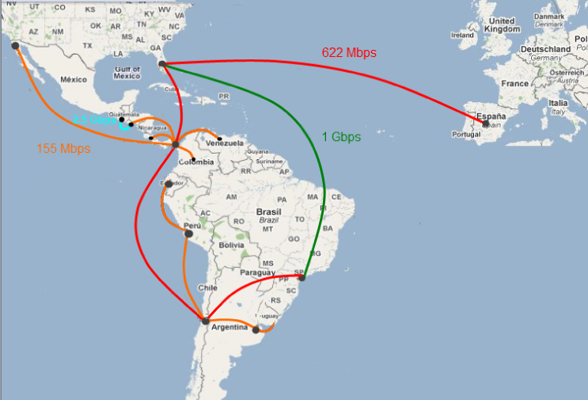
Figure no. 1 Future CLARA’s topology April 1/2010

The connection of San Jose – Costa Rica is shown to Panama, and this is not the current situation and there is no change in the link defined jet, but CLARA will have to move this connection as it is shown in the graph by June 2010.

BASIC INFORMACION

In the following table are described the main characteristics of the hired links:

Guatemala – El Salvador’s link information
Interface type | DWDM
Bandwidth | 2.5 G
Provider | Navega
ODF Connection | SC/PC Connector
Standard | ITU-T G.694.1
Point 1 (Guatemala) Address | Universidad del Valle de Guatemala  18 avenida 11-95 zona 15. V.H. III  Tels. (502) 2364-0336/40
Point 2 (El Salvador) Address | 63 Ave Sur y Alameda Roosevelt,  Centro Financiero Gigante torre A nivel 9, San Salvador.

For Guatemala’s link, the provider agreed to deliver the circuit with two 1 Gigabit Ethernet interfaces. CLARA will use this option because it will represent lower costs in the equipments.

El Salvador – Panama’s link information
Interface Type | STM-1
Bandwidth | 155 Mbps
Provider | Columbus
ODF Connection | SC/PC Connector
Point 1 (Panama) Address | Gailard Ave, Corozal East, Building No 265 Balboa - Ancón – Panama
Point 2 (El Salvador) Address | 63 Ave Sur y Alameda Roosevelt,  Centro Financiero Gigante torre A nivel 9, San Salvador.

Guayaquil – Lima’s link information
Interface Type | STM-1
Bandwidth | 155 Mbps
Provider | Internexa
ODF Connection | SC/PC Connector
Point 1 (Guayaquil) Address | Miguel H. Alcivar con Castillo de Levi - cerca de la Radio Sucre
Point 2 (Lima) Address | Av. Pedro Miotta 410 San Juan de Miraflores - Lima, Peru

SPECIFIC TASKS

Guatemala – El Salvador installation

The Guatemala – El Salvador link is the first OTU1 in Central-America and common practice is to deliver it with a DWDM interface. This type of interface requires that CLARA buys DWDM capable equipments on each side, and it presents a challenge between equipments price and bandwidth efficiency. Due to the cost of these interfaces, CLARA asked Navega the delivery of the link in 2 Gigabit Ethernet interfaces, and the provider agreed.

In Guatemala is optional to have a switch or router, due to that all the interfaces will be Ethernet exclusively. In El Salvador it is required a router, due to the STM-1 interface that will connect it to Panama and the transit of Guatemala’s traffic through this PoP. In the following figure is shown the technical solution for the link:

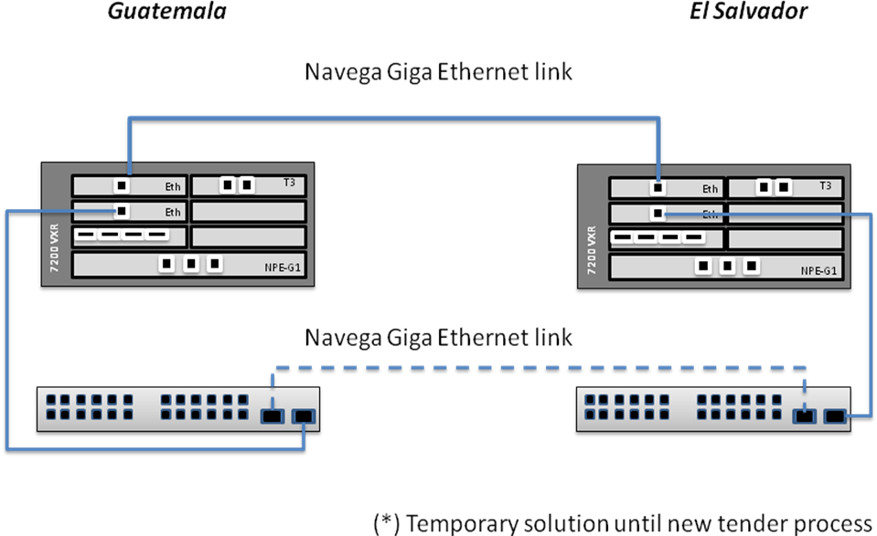
Figure no. 2. Guatemala – El Salvador link connections

The tasks required for this links and the date limits are the following:

- Define PoP’s locations (January 15/2010): Define where the links will be installed and if there could be change in locations.
Responsible: Gustavo Garcia (Technical Manager)

- Define the required equipment and request quotes to providers (January 20/2010): The equipments required on each side of the link will be defined by the NEG and the quotes must be requested. After the analysis with Florencio Utreras and the NEG, the best option is to use the current router and switch equipments as temporary solution until the next equipments tender process that will take place in April 2010.

Responsible: Gustavo Garcia (Technical Manager), Alex Moura (NEG)

- Send sales orders to providers (February 15/2010)
Responsible: Gustavo Garcia (Technical Manager), Mark Urban (CFO)

- Request El Salvador’s tie down information to provider/NRENs (January 18/2010)
Responsible: Alex Moura (NEG)

- Request Guatemala’s tie down information to provider/NRENs (January 18/2010)
Responsible: Alex Moura (NEG)

- Request cross connections to providers (March 4/2010)
Responsible: Gustavo Garcia (Technical Manager), Florencio Utreras (Executive Director)

- Installation of cards in the equipments (March 19/2010)
Responsible: Gustavo Garcia (Technical Manager), Alex Moura (NEG)

- Link activation (March 19/2010)
Responsible: Gustavo Garcia (Technical Manager), Alex Moura (NEG)

El Salvador – Panama installation

The El Salvador - Panama's link is a STM-1 SDH connection. This link requires the installation of STM-1 cards in Panama and El Salvador’s routers. Today, the router in Panama has 4 interfaces, all of them occupied, and the router in El Salvador has 1 already occupied too. In Panama, CLARA needs to buy a STM-1 card for Panama’s router and replace it for a DS3 card that is installed on it. The following list contains the tasks for the El Salvador – Panama's link activation:

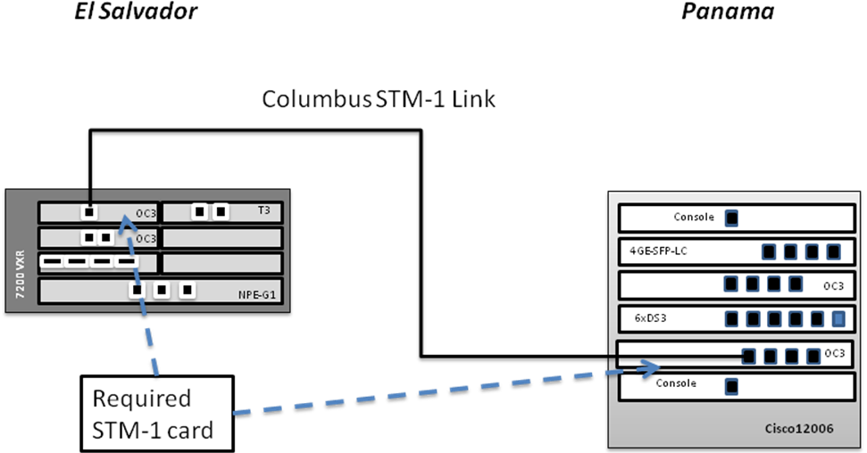

Figure no. 3. El Salvador – Panama link connections

- Complete the steps a) to d) of the Guatemala to El Salvador installation: The installation of the El Salvador – Panama’s links depends of the presence of the required parts.

- Request Panama’s tie down information to Global Crossing (February 18/2010)
Responsible: Gustavo Garcia (Technical Manager)

- Request El Salvador’s tie down information to provider/NRENs (February 18/2010)
Responsible: Alex Moura (NEG)

- Request Panama’s cross connect to Global Crossing (March 3/2010)
Responsible: Gustavo Garcia (Technical Manager)

- Install STM-1 card or free STM-1 interface (March 19/2010)
Responsible: Gustavo Garcia (Technical Manager)

- Activate the El Salvador – Panama link (March 19/2010)
Responsible: Gustavo Garcia (Technical Manager)

Guayaquil - Lima installation
The El Guayaquil-Lima's link is a STM-1. This link requires a new STM-1 card in Guayaquil’s router, and in Lima the interface is available. The following is the list of the tasks required for this link’s activation:

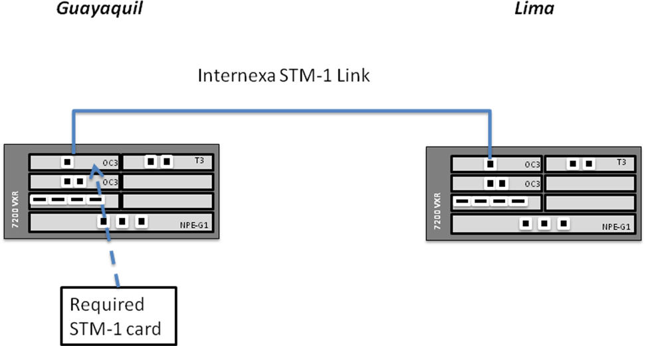

Figure no. 2. Guayaquil - Lima link connections

- Quote the STM-1 card required for Guayaquil’s router (January 25/2010)
Responsible: Gustavo Garcia (Technical Manager)

- Send sales order to providers (January 25/2010)
Responsible: Gustavo Garcia (Technical Manager), Florencio Utreras (Executive Director)

- Request Guayaquil’s tie down information to Internexa (January 25/2010)
Responsible: Gustavo Garcia (Technical Manager)

- Request Lima’s tie down information to Internexa (January 25/2010)
Responsible: Gustavo Garcia (Technical Manager)

- Request Lima’s cross connect to Internexa (February 15/2010)
Responsible: Gustavo Garcia (Technical Manager)

- Request Lima’s cross connect to Internexa (February 15/2010)
Responsible: Gustavo Garcia (Technical Manager)

- Install card in Guayaquil’s router (March 10/2010)
Responsible: Gustavo Garcia (Technical Manager), Alex Moura (NEG)

- Activation of the Guayaquil – Lima’s link (March 15/2010)
Responsible: Alex Moura (NEG)

REQUIRED EQUIPMENTS SUMMARY

